|  |  |
| --- | --- |
| C:\Users\kater\Downloads\DALL·E 2024-01-27 18.07.14 - A black and white drawing of a cyber cat wearing a classical suit, training classifiers and regressors. The cyber cat, with its mechanical and robotic.png Part 2. **Basic algorithms**  Shylo, how do you feel about Python now? It's not so scary, is it?  Well, at least it works well with tinned cat food. But what about learning? Machine learning, I mean...  Nothing yet, but imagine this: You are very hungry and you are looking for something yummy and light. How long would you choose when there are lots of dishes on the menu and you can't wait to eat?  C:\Users\kater\Downloads\DALL·E 2024-01-26 15.57.39 - A black and white drawing of two hungry cats, one organic and one cyber-cat, reading a long menu. The organic cat and the cyber-cat are depicted sitti.png  Besides, you are not alone, you are with a friend who has a different taste.  When I'm with a friend, we can't even finish reading the menu.  But the menu doesn't say "yummy and light". It says how much it costs, how the food is made up, and sometimes reviews, if we're talking about the online menu. | |
| C:\Users\kater\Downloads\DALL·E 2024-01-26 15.30.05 - A black and white drawing illustrating the concept where an algorithm studies cat behavior and taste preferences in a cat-themed restaurant setting to.png  The next time the menu changes, but the trained algorithm can still satisfy your request. Even if you want something high in calories. The main thing is that such a category exists.  To make a decision, you can ask an experienced waiter who knows the customers’ habits well. Or you can teach a machine to recognize “yummy and light” dishes.  Meanwhile, if you eat at the same place for a long time, an algorithm can study your behavior and taste preferences to offer you something you will definitely like and make the restaurant money.  Observing a lot of customers, the restaurant can predict how busy it will be during the day, the demand for different dishes, its own income, etc. | |
| C:\Users\kater\Downloads\DALL·E 2024-01-26 21.14.09 - A black and white drawing of cats with different foods queuing to be weighed. In the queue, each cat is holding a different type of food, creating a v копия.pngx  Not exactly, if you have a lot of data and a lot of money, you will use something powerful like neural networks, for example.  Mylo, how does the machine know which categories I'm interested in, or what the demand for certain products will be tomorrow morning?  In other words, we need to indicate that a particular observation belongs to a particular class. In this case, the label is discrete and we are dealing with a **classification** task (e.g. slim cats vs. fat cats).  **Supervised** algorithms are more accurate. But to train them, we need **labeled** **data**.  Remember, we talked about supervised and unsupervised learning?  If a certain event occurs under certain conditions, the label will be continuous and we will have a **regression** task (e.g. if this cat eats 100 grams every 4 hours, how heavy would it be?)  In **unsupervised learning**, labeling is not required. E.g. **clustering** allows to find sets of similar cases on its own.  However such algorithms work worse and are used less.  Well, you might talk about very complicated algorithms. | |
| C:\Users\kater\Downloads\DALL·E 2024-01-26 20.03.18 - A black and white drawing of a cat sleeping on a large pile of receipts, with a cyber-cat that looks more like a traditional cat sitting on the floor .png  But if we are talking about a small business, classic algorithms will do the job. In fact, they are the most commonly used. | |
| C:\Users\kater\Documents\Comics\DALLE\Part 2.1\DALL·E 2024-01-26 14.46.00 - A black and white drawing of a cyber-cat sitting on the floor, with two cages beside it, separating fish from birds. The cyber-cat, with its mechanica.pngC:\Users\kater\Downloads\DALL·E 2024-01-27 18.09.04 - An illustration capturing the concept of classifiers used in various scenarios related to cat food. The drawing includes a computer screen with an ema.png  **2.1 Classification**  Classifiers can also be used to recognise handwritten letters and numbers, for example, if the message was delivered by a carrier pigeon. Or even identify suspicious transactions if someone hacks into your cat food store's payment system.  Classifiers are really cool! They can filter the spam that arrives in your inbox from cat food sellers, look for similar documents, and detect the language of these advertisements or their tone.  Of course they can. But first, you have to mark the ones you have already eaten as tasty or not. That will be a “teacher”.    Considering basic ML algorithms, let's start with classification. This seems the easiest. | |
| I wonder if these algorithms will be able to distinguish good cat food from bad. | |
| C:\Users\kater\Documents\Comics\DALLE\Part 2.1\DALL·E 2024-01-27 18.43.58 - A black and white drawing of a cyber-cat planting a cyber-tree, surrounded by various types of neighbors including cyber-neighbors, naive neighbors, a.pngAre | C:\Users\kater\Downloads\DALL·E 2024-01-29 11.30.13 - A black and white drawing of a cyber cat reading two lists one with regular words for cats and one with spam words, including a count of each word. T копия.png  For example, I have two lists. The first is the words frequency from normal emails: Cat – 20; Dog – 50; Food – 100; Restaurant - 80.  The second is from SPAM: Cat – 50; 100% - 100; Free - 100.  Let's create a simple spam classifier using just one word - "CAT".  Third, make a decision: if I see the word "CAT" in an email, I'll send it to the spam. folder.  Second, compare them: $\frac{5}{7}>\frac{2}{7}$.  Not so many, but the most popular are:  - Naive Bayes,  - Logistic Regression,  - K-Nearest Neighbors,  - Support Vector Machines,  - Decision Trees.  -  Good. Are there many classifiers?  Let's look at them in detail. |
| C:\Users\kater\Documents\Comics\DALLE\Part 1\5 (1).png  **Naive Bayes** seems to be the simplest. Almost all spam filters used to work with this algorithm. The classifier counted how many times a particular word (e.g. "cat") appeared in spam and how many times it appeared in normal email. It multiplied these two probabilities using the Bayesian formula, added up the results for all the words, and marked the message as spam or not.  First, we calculate Bayesian probabilities: | |
| C:\Users\kater\Documents\Comics\DALLE\icons\m2.pngC:\Users\kater\Documents\Comics\DALLE\icons\m1.pngC:\Users\kater\Documents\Comics\DALLE\icons\m2.png  It's like drawing a curve to separate flying creatures from crawling ones. It allows you to develop the best hunting strategy.  This algorithm also helps you to understand which characteristics of the victim are important and which are not.  **Logistic regression** helps you choose between two linearly separated options, such as YES or NO. | C:\Users\kater\Downloads\DALL·E 2024-01-29 12.12.46 - Create an illustration featuring a cyber-cat observing a scene where an S-shaped snake separates birds from mice. The cyber-cat, with a futuristic and копия.png |
| C:\Users\kater\Downloads\DALL·E 2024-01-29 13.17.43 - A black and white drawing of a cat surrounded by a mix of fat and skinny friends, all engaged in a voting process to decide whether the cat is fat or .png  The **K-nearest neighbours** algorithm looks at the nearest 'k' things around an object to see what most of them are like. Then it classifies the object as the majority around it. | It's like if you have fat and skinny friends and they vote to decide whether you're fat or skinny. |
| Think of it as making the widest possible path in your garden between the lawn and the fish pond.  **Support Vector Machine** (SVM) tries to draw lines to separate different groups with as much space between them as possible. | C:\Users\kater\Downloads\DALL·E 2024-01-29 13.36.14 - A black and white drawing of a cyber-cat trying to make the widest possible paths in a garden. On one side of the path, there is only grass, and on th копия.png |

|  |
| --- |
| C:\Users\kater\Documents\Comics\DALLE\Part 1\4 копия.png  **Decision trees** (DT) are used in areas of high responsibility, where life and death are at stake.  DT formulates the task as a set of YES/NO questions, allowing the logic of the algorithm to be understood.  **C:\Users\kater\Downloads\DALL·E 2024-01-29 13.28.17 - A black and white drawing of a cat walking down a street where various dogs are present. The scene is from the perspective of the cat, observing the d.png**  Imagine you are walking down the street where there are many dogs. How can you recognise the one that will chase you?  If you've seen a lot of dogs, you might have an idea of their breed, sex, age, owners and, most importantly, which ones are dangerous.  There is no problem in building such a classifier. The problem is whether the result can be trusted. DT will help you to decide. |

 Case 2. **Practice classification**

Let's practice classifiers with the data we already analysed. By now you should know how to download the saved dataset.

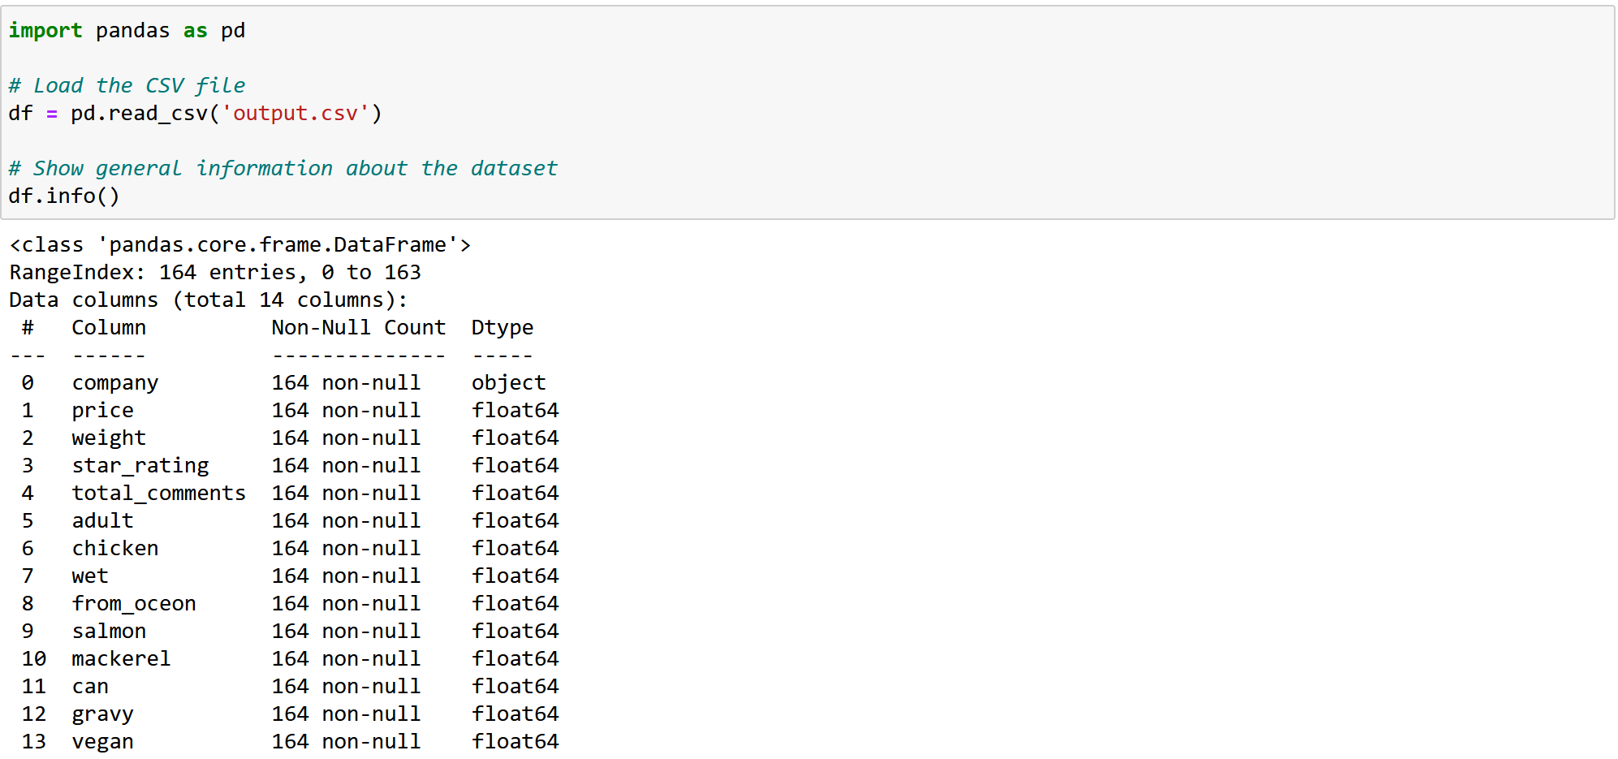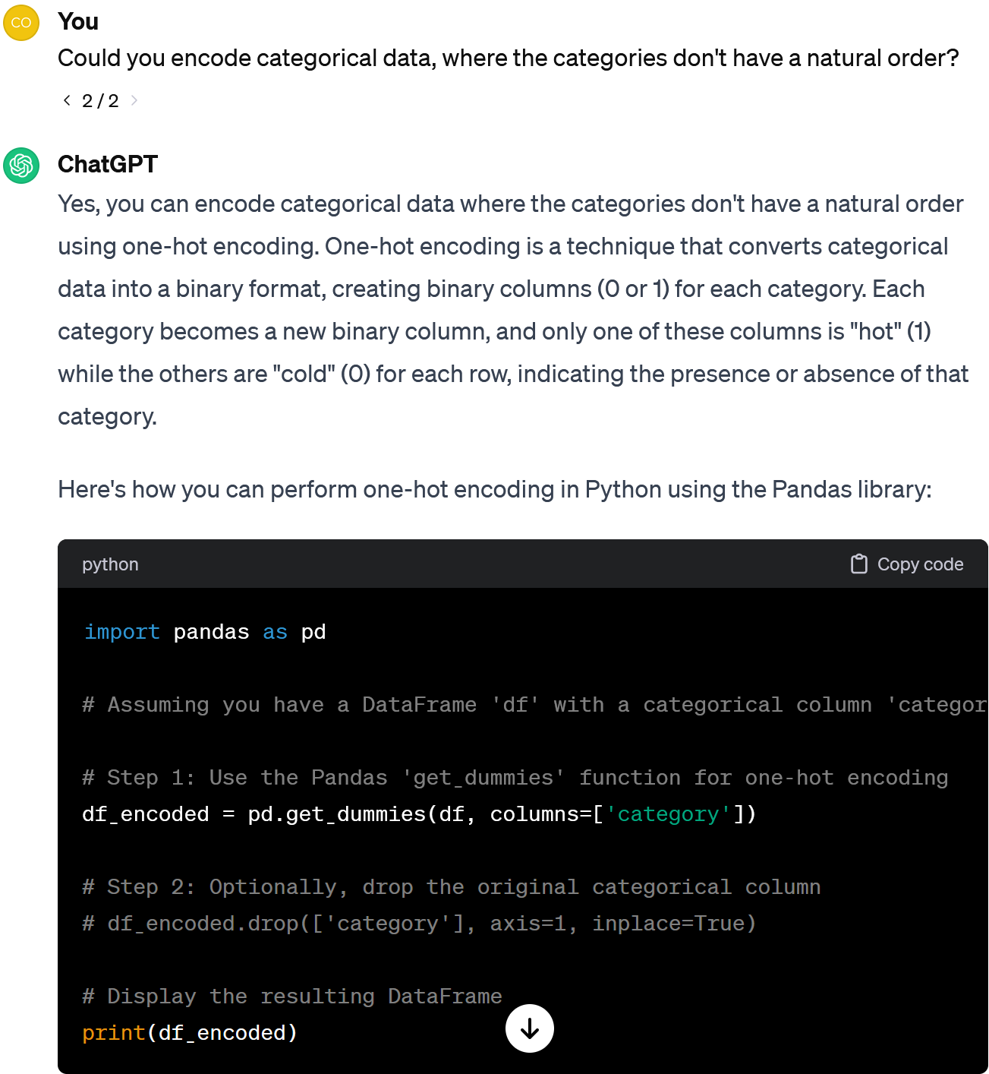

Yes, we should encode categorical data first.

Am I right in thinking that classifiers work with numerical data only?

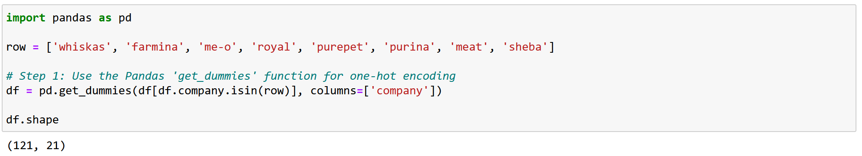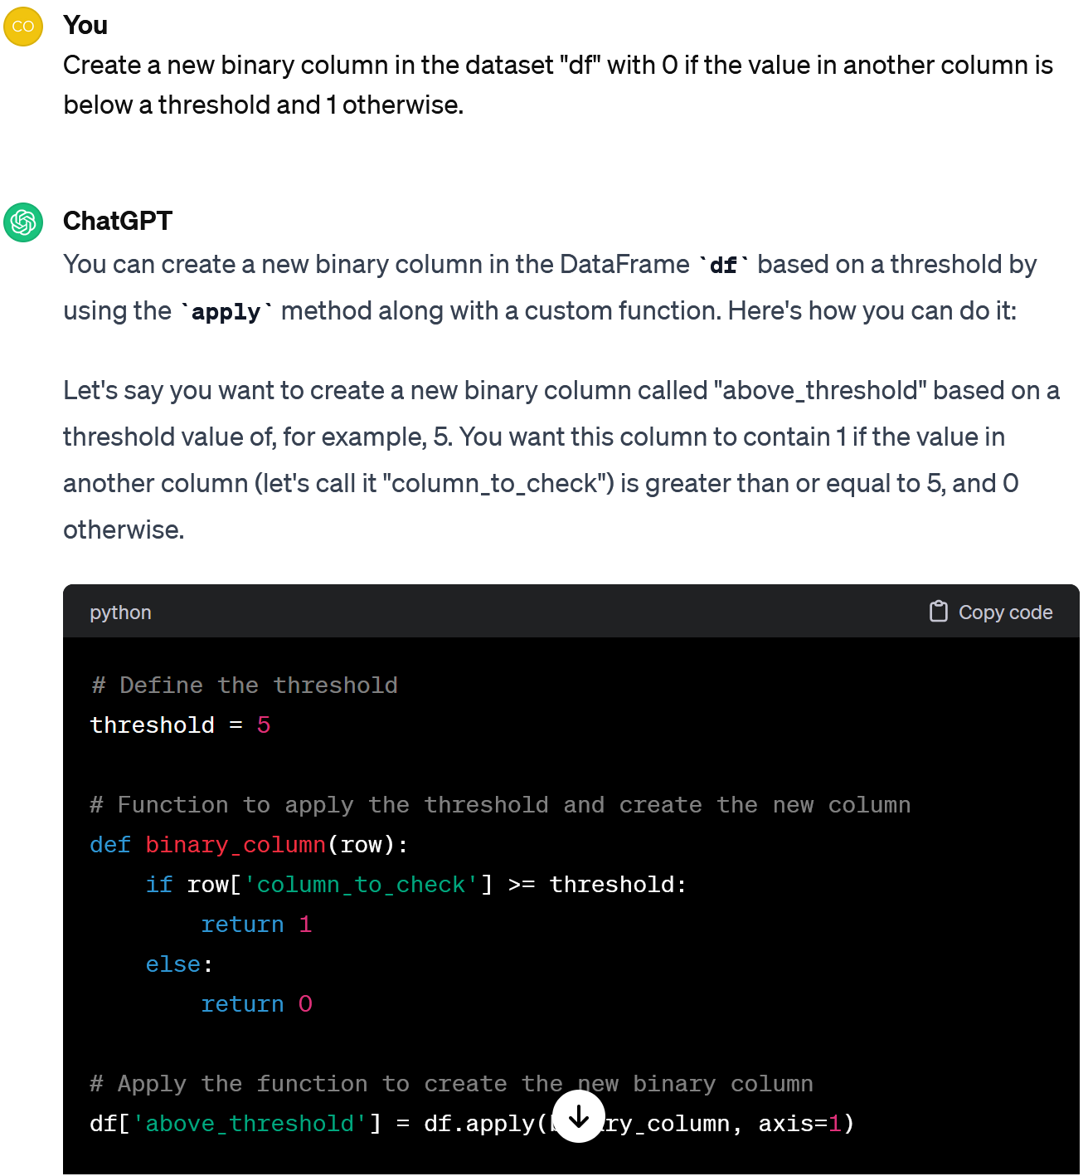

There are only 121 observations left, but the number of columns has increased from 14 to 21.

Ok, if it's higher than 4.5, let's consider the food as good, otherwise as bad.

Let it be star_rating. You don't mind?

Who would be a "teacher" to distinguish good cat food from bad? I don't see such a feature.

As I recall, there were 41 brands, but only 7 of them were well represented. Let's proceed with them.

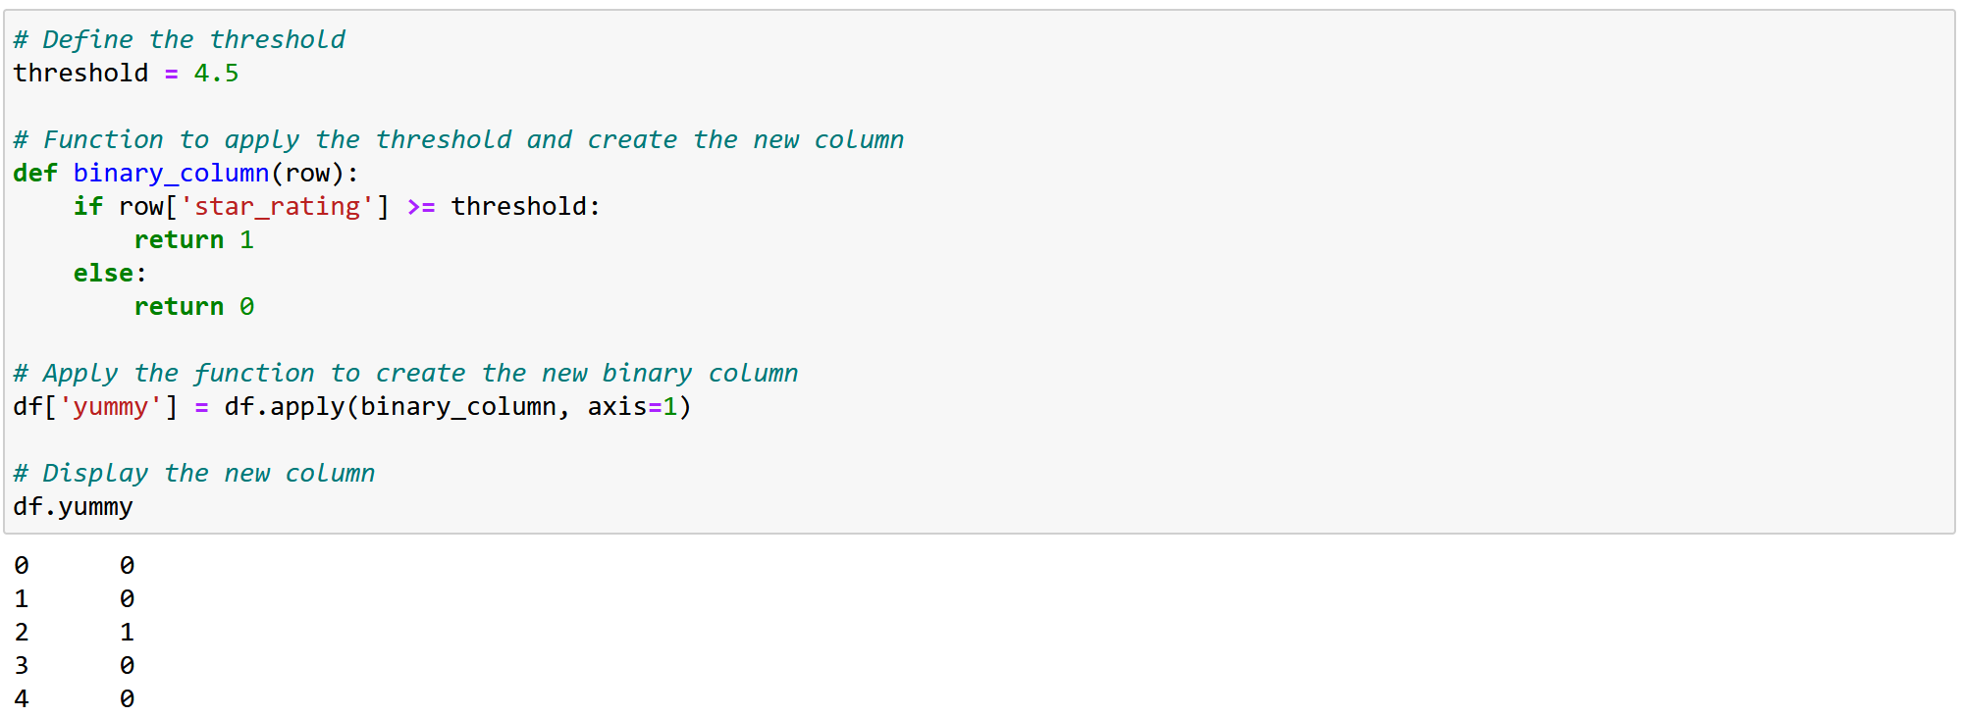

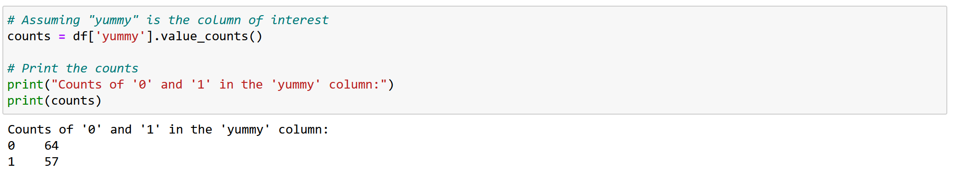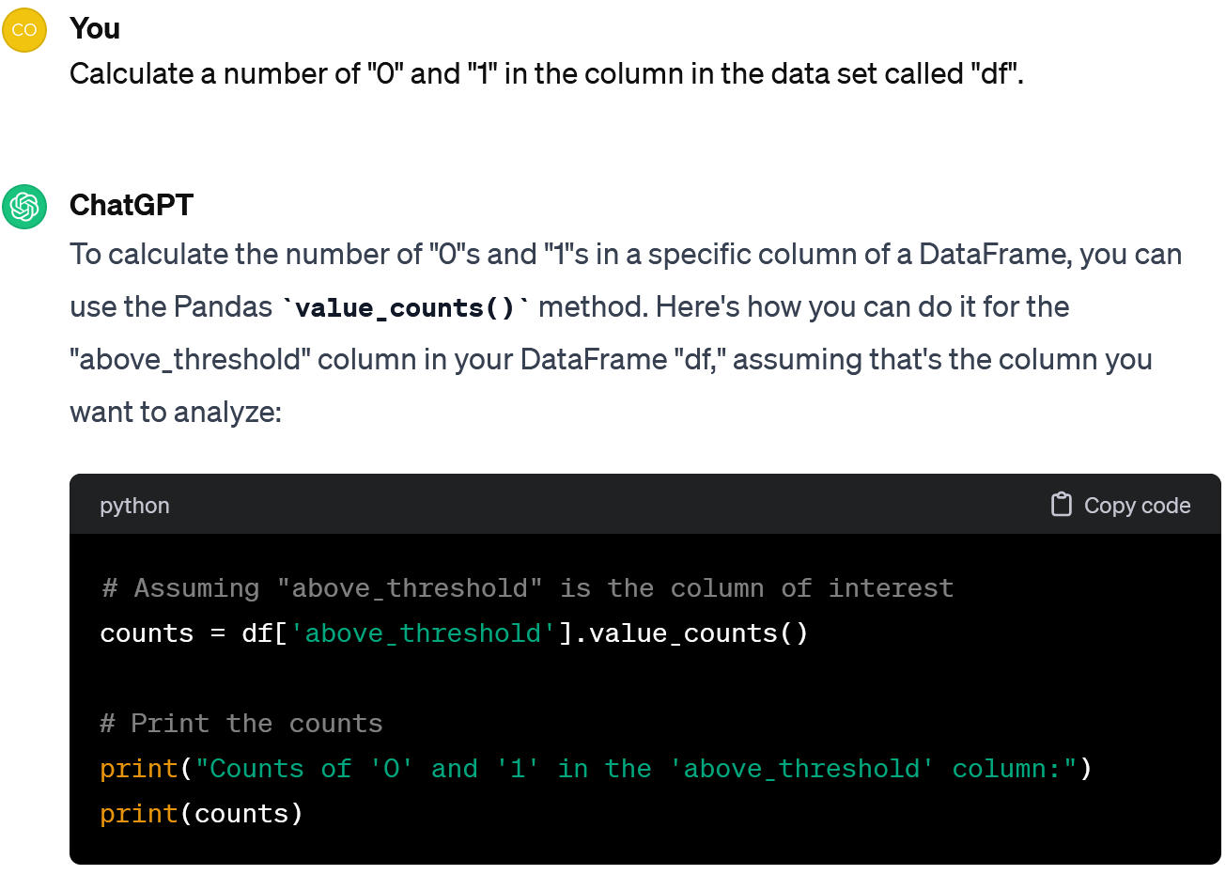

57 products are marked as good, 64 as bad. Accepted!

So now we have a new feature called "yummy".

Yes, let's check that the number of good and bad cases is comparable and the classes are balanced.

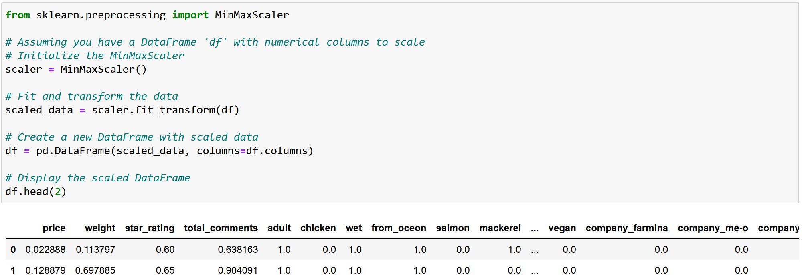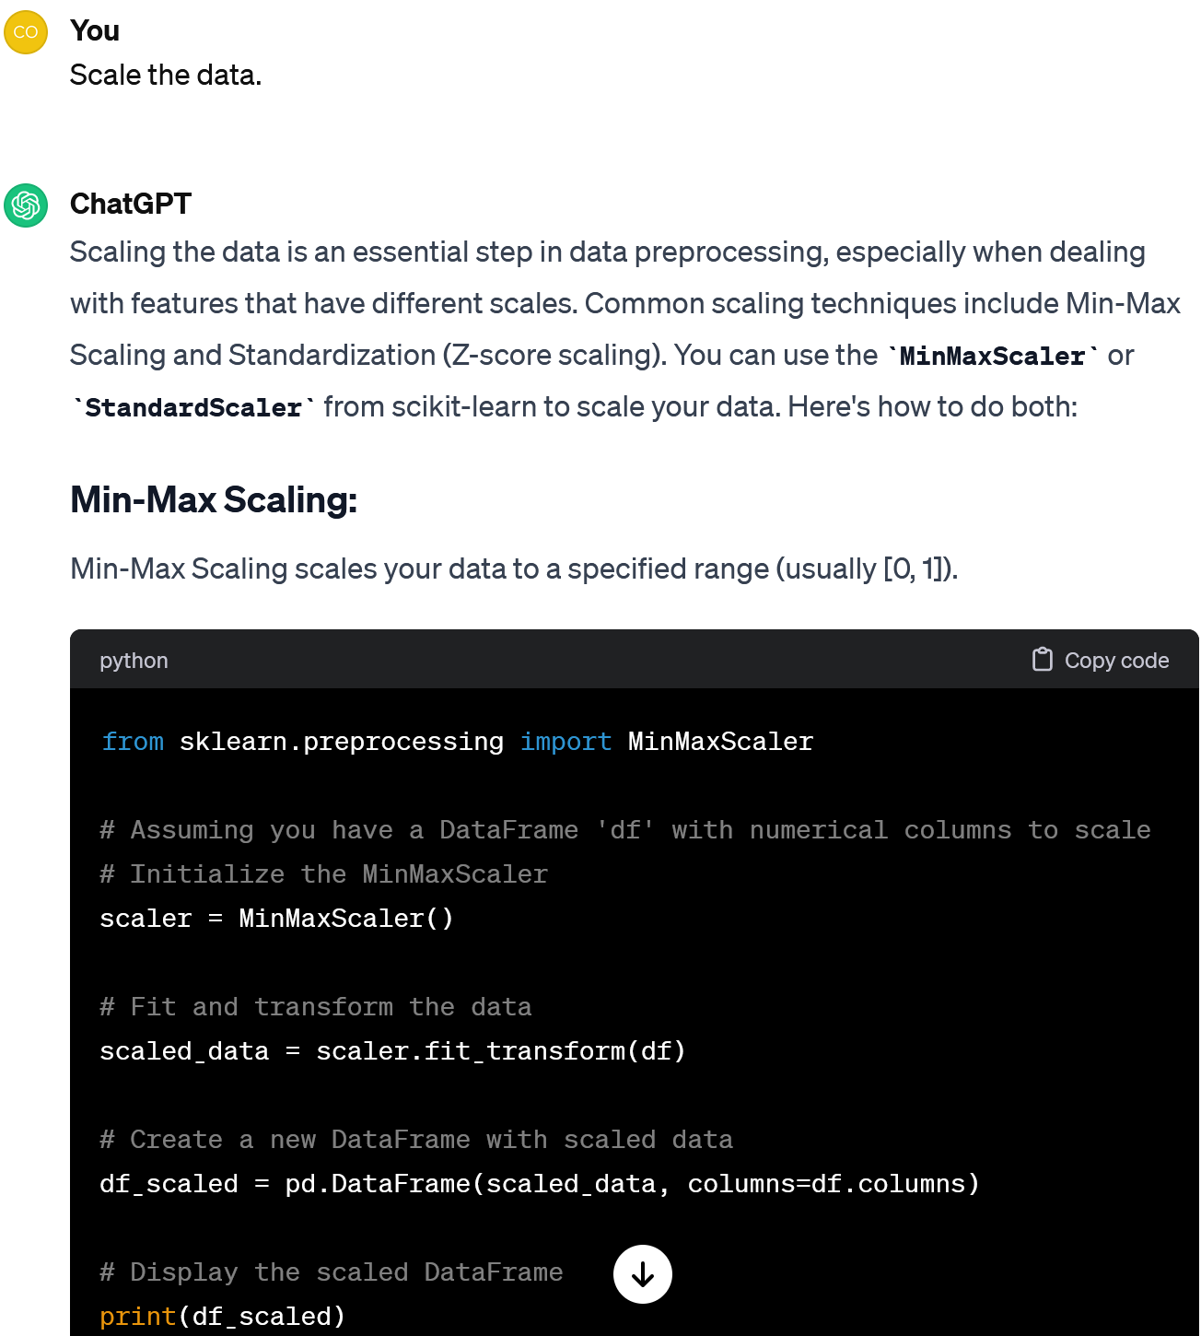

We used MinMaxScaler to make all features vary from 0 to 1.

Should we also make features comparable? If I'm not mistaken, 17 of the 21 features are binary (0/1), but there are 4 that vary in a wider range.

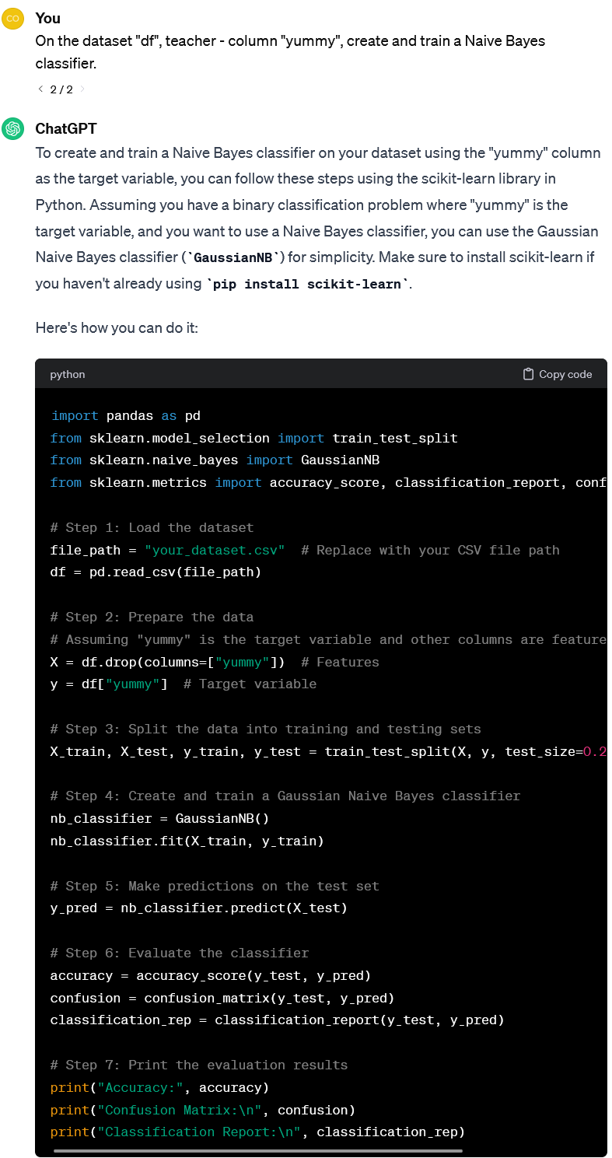

Note that for all basic ML algorithms we will use the [scikit-learn library in Python](https://scikit-learn.org/stable/index.html). If you want to go deeper into ML, you should read its tutorials rather than asking the ChatGPT.

Well, now let's train the Naive Bayes classifier!

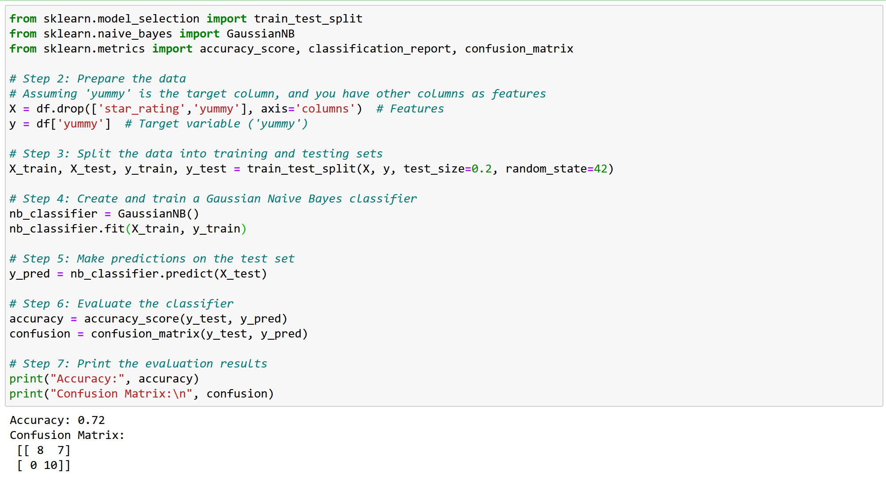

In Step 3, we split the data into training and test sets, keeping 80% of the data to train the model (96 cases) and the rest to test it (25 cases).

What would you say about the results?

Frankly, I'm not too happy. According to Confusion Matrix, it detects good food quite well (all 10 cases). However, it is often wrong about bad food (7 out of 15 times).

This means that it only gets 72% right.

In Step 5 we made predictions on the test set and compared the results with the data we had in Step 6.

We've already done Step 1.

In Step 2, we select features X and fix a "teacher" column Y - "yummy".

In Step 4 we created and trained a Gaussian Naive Bayes classifier. We call it nb_classifier.

Note, we have dropped the columns related to the "teacher" from X.

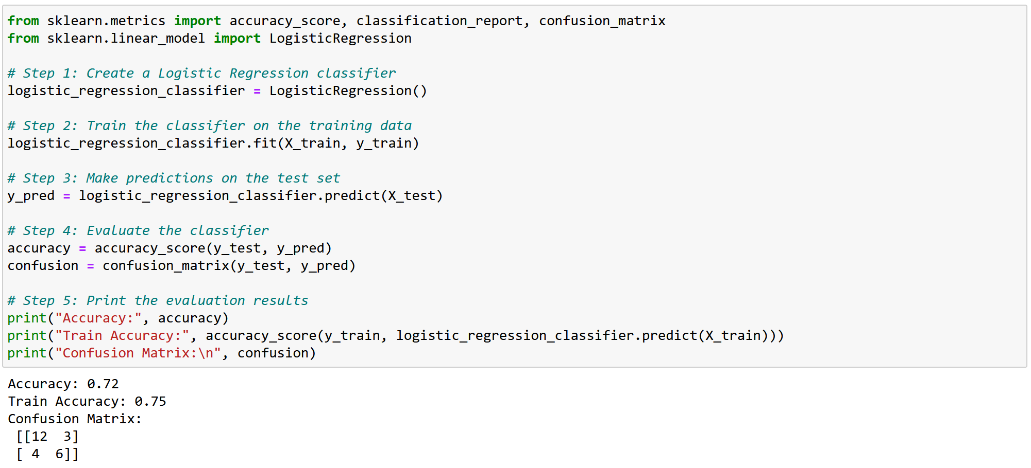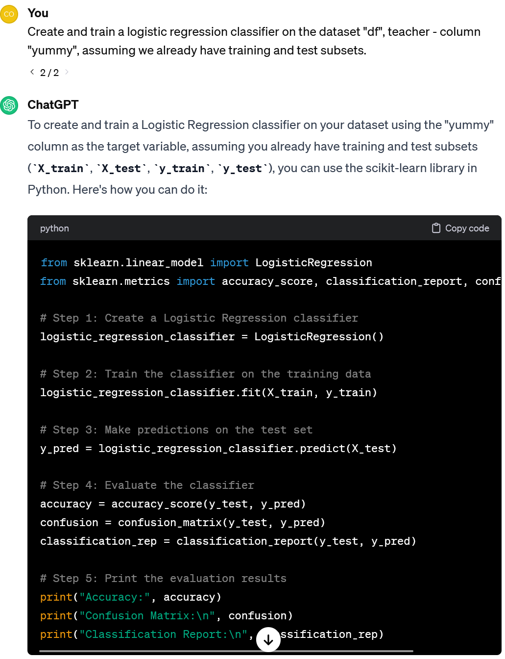

Just the same, but this time it handles the bad food better (12 of 15 recognized correctly).

Anyway, 72% accuracy is not enough.

So what about the results?

This time we need to specify the prompt, bearing in mind that the data has been already prepared.

Look, the rest of the code is almost the same this time. Only the function differs.

Then let's try another classifier. Let it be logistic regression.



Hmm, can we somehow understand how it makes a decision whether the food is good or bad?

Let’s ask.

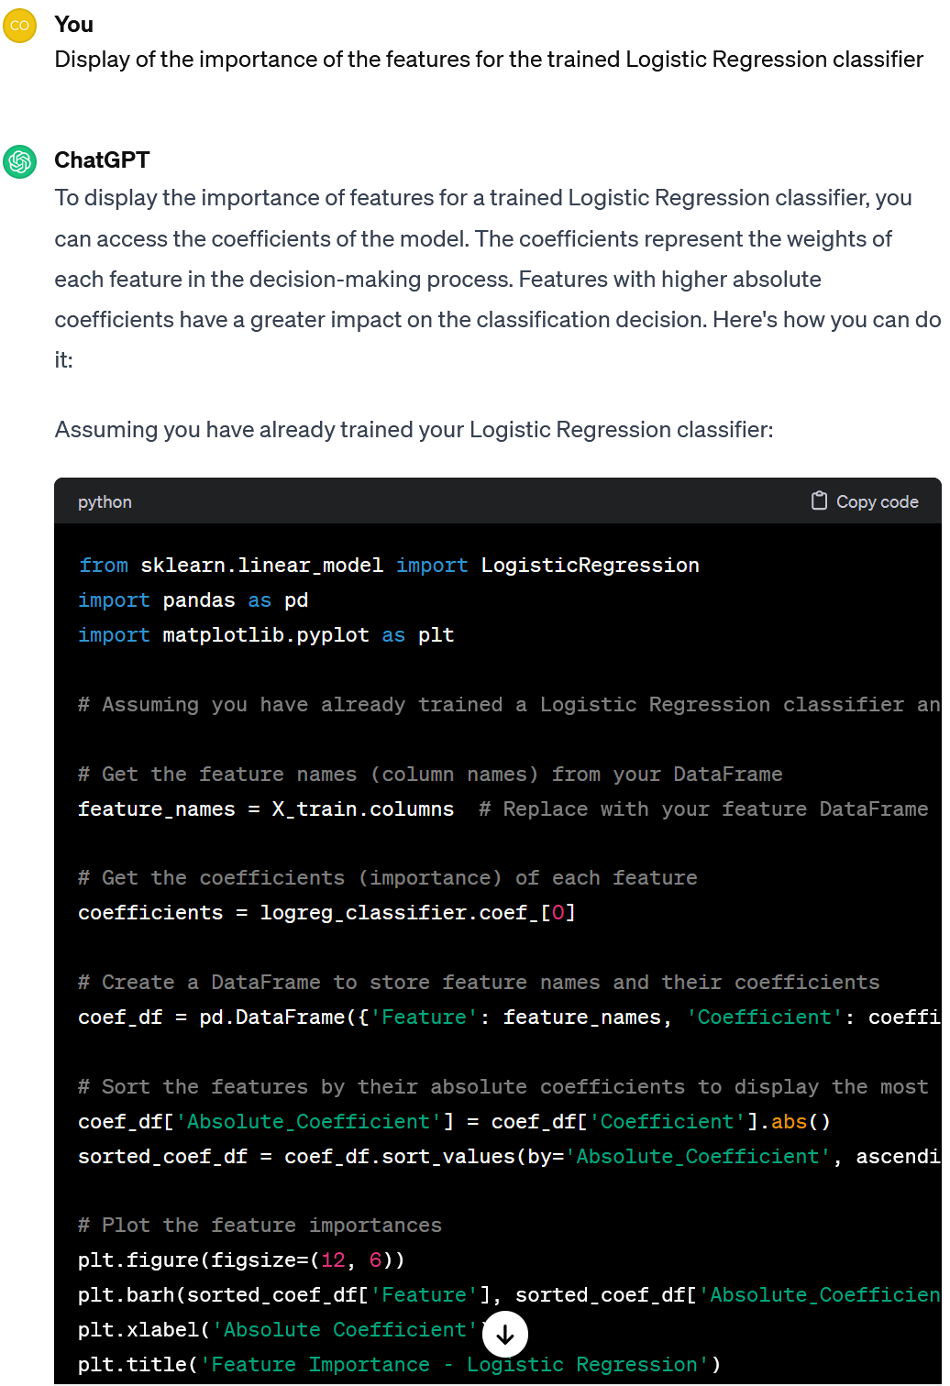



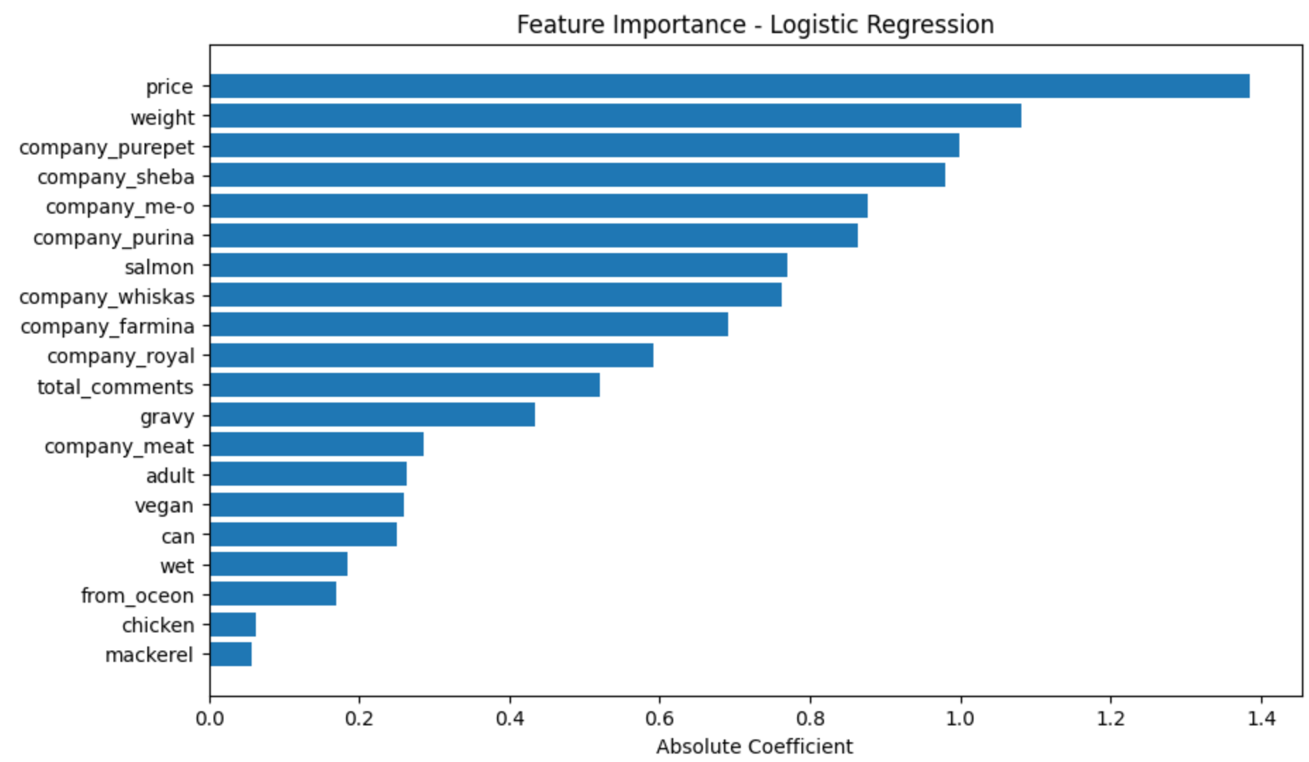

Look, it makes a decision mainly on *price* and *weight*. At the same time, other features are also important.

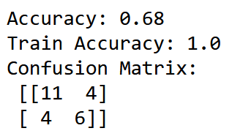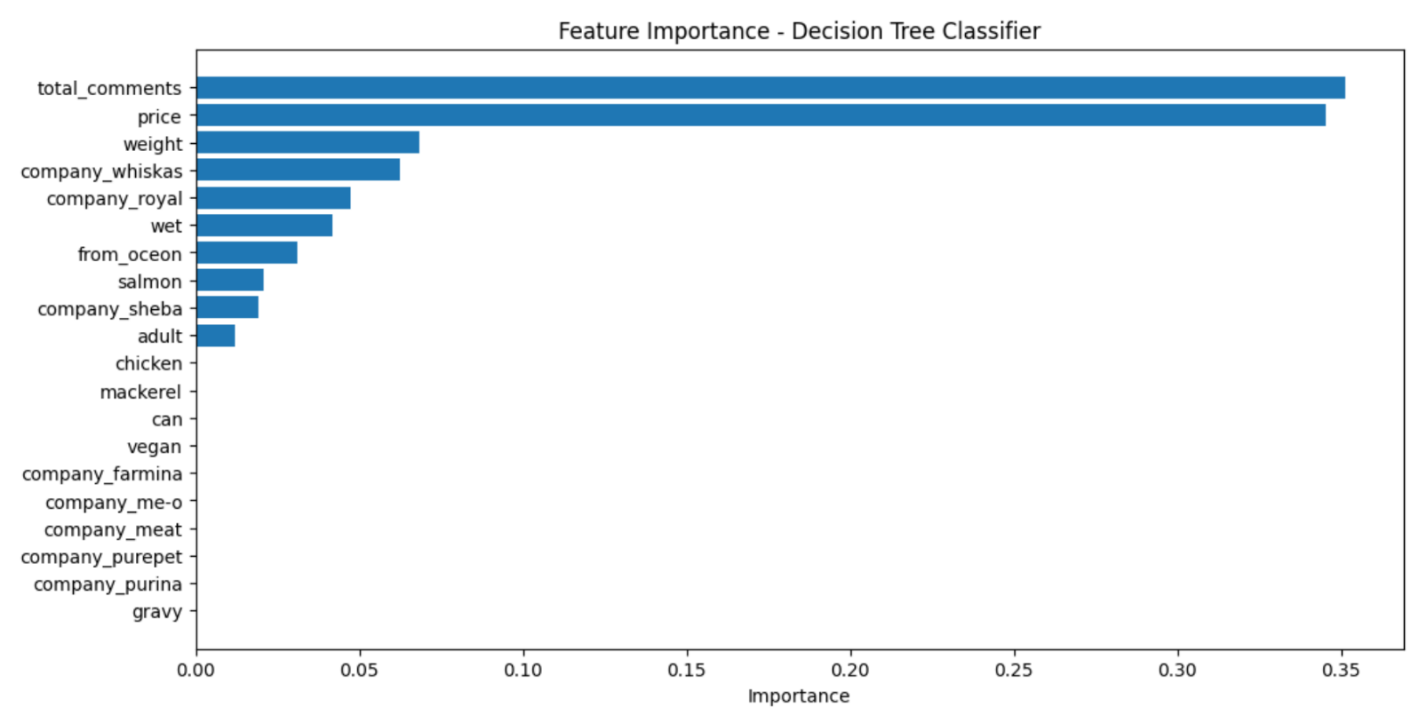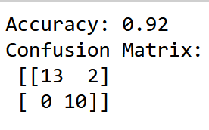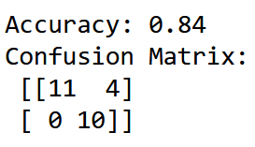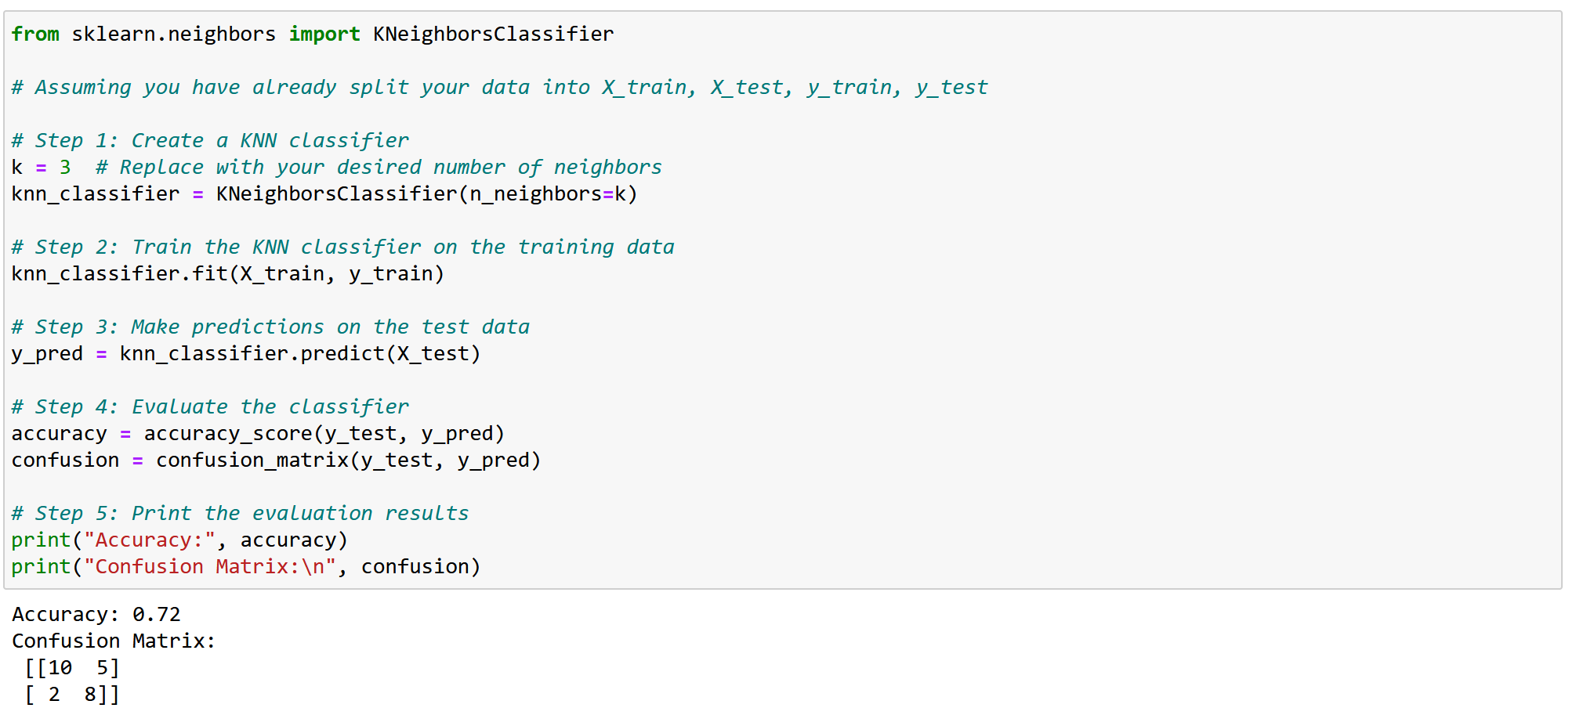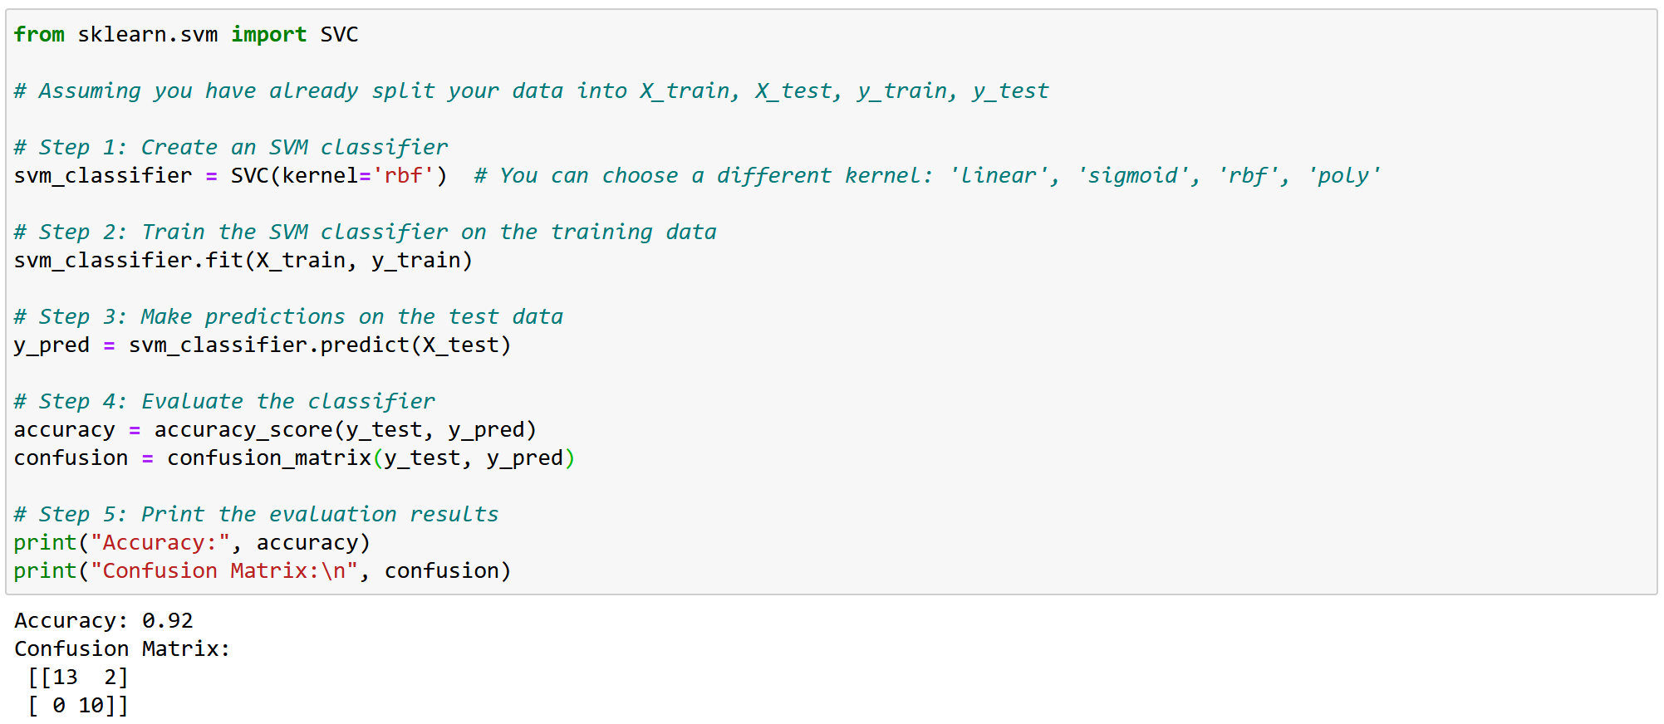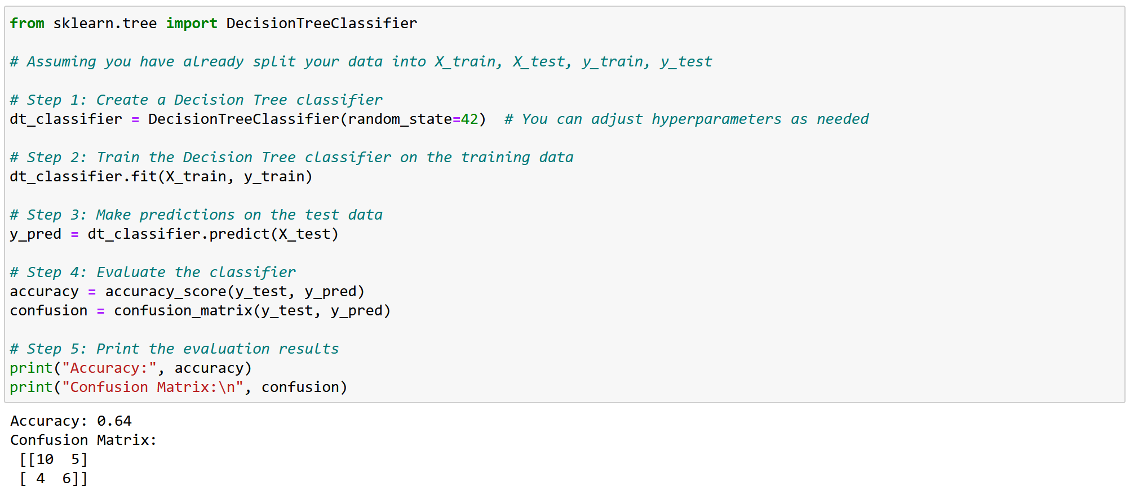

Note, that the importance of DT features differs from the Logistic Regression - the most important feature here is *total_comments*.

Decision Tree performs worst on the test data (with 68% accuracy). This model is overfitted - the function is too close to a limited set of training points.

SVM performs best, with an accuracy of 92%. It was wrong in only 2 cases of bad food recognition.

KNN performs quite well, with an accuracy of 84%.

Let's make a long story short and just look at the results, as we only need to adjust the functions for the rest of the classifiers.

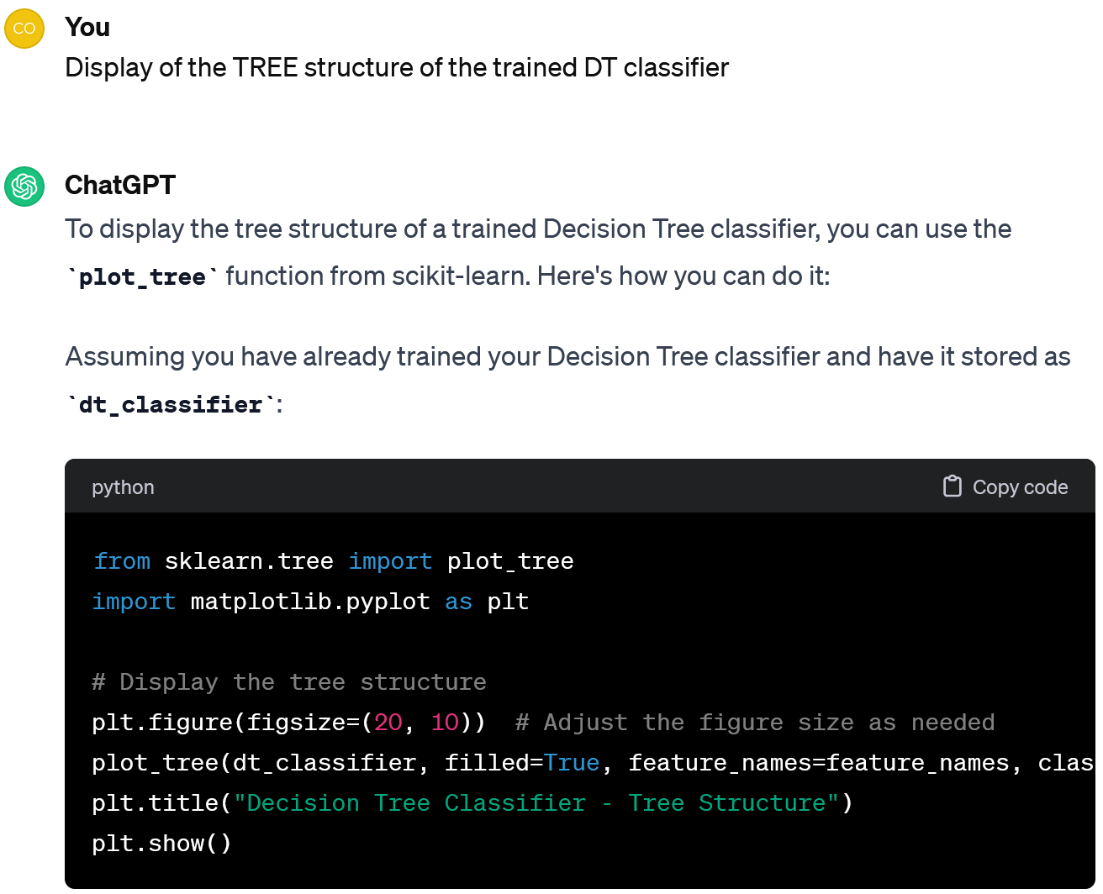

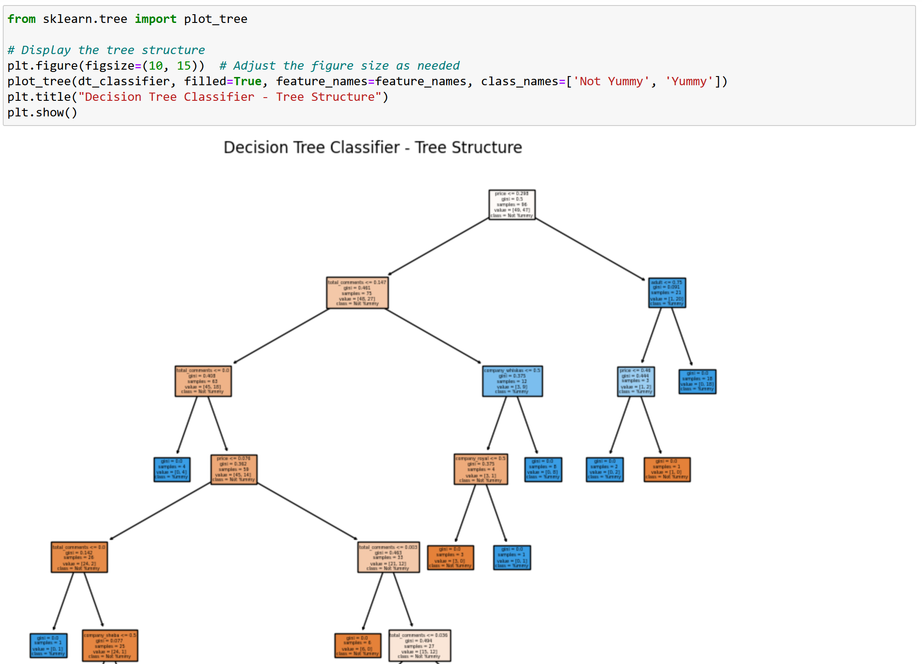

Let's summarise. To create a Classifier, one have to:

1. Prepare the data: code the categorical features, add the "teacher" column and check that the classes are balanced, scale the data and split it into training and test sets.

2. Build and train Classifiers, e.g. Naive Bayes, Logistic Regression, K-Nearest Neighbours, Support Vector Machines, and Decision Trees.

3. Compare their results (e.g. Accuracy and Confusion Matrix) and select the best one.

Anyway, I like DT because it allows to analyse explicitly how the decision gets made.

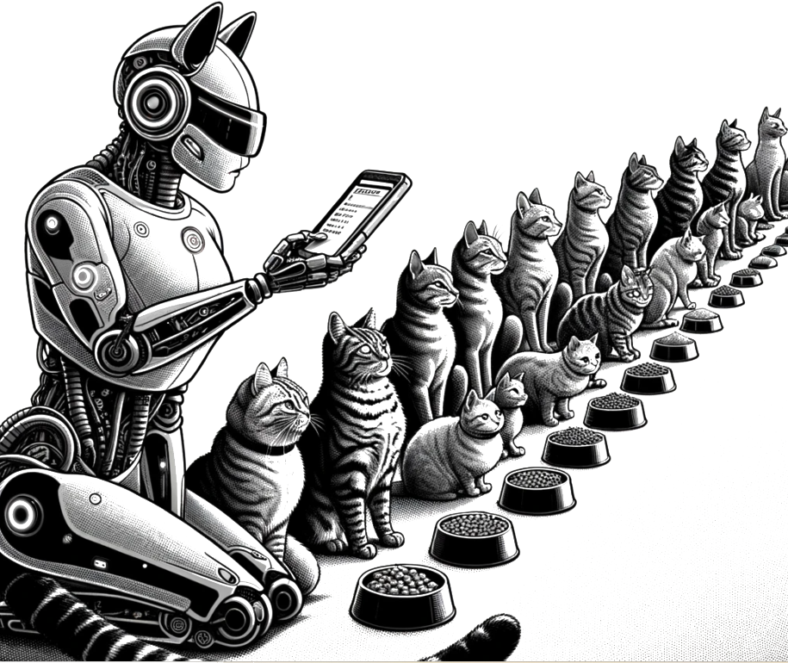

2.2 **Regression & Ensembles**

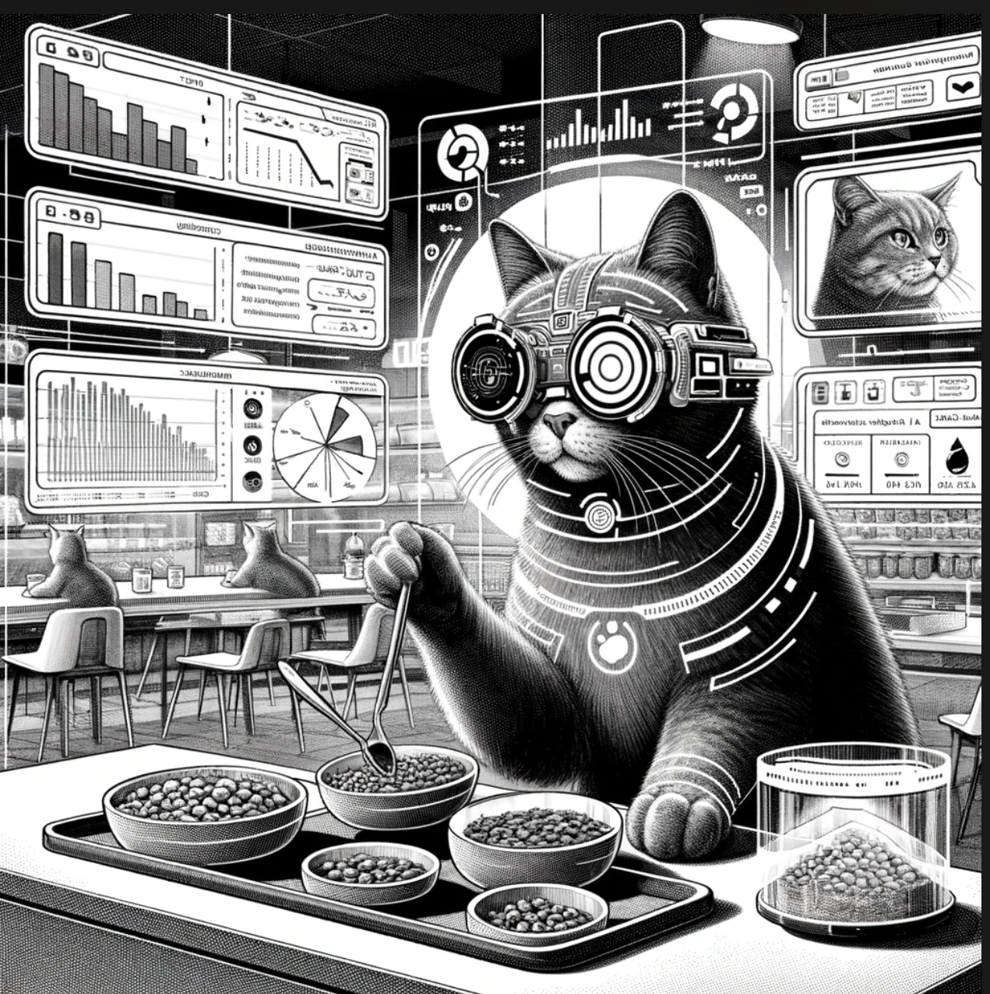

Regression is very close to classification.

It does this mathematically precisely - considering the average distance to get to each point.

The machine tries to draw a line that shows the dependency on the average / over time.

But instead of a category, it predicts a number – e.g. demand for food in the pet shop, cost of a dish for its ingredients, daily traffic by a cat bowl, etc.

Regression is perfect for any task where there is a time dependency.

**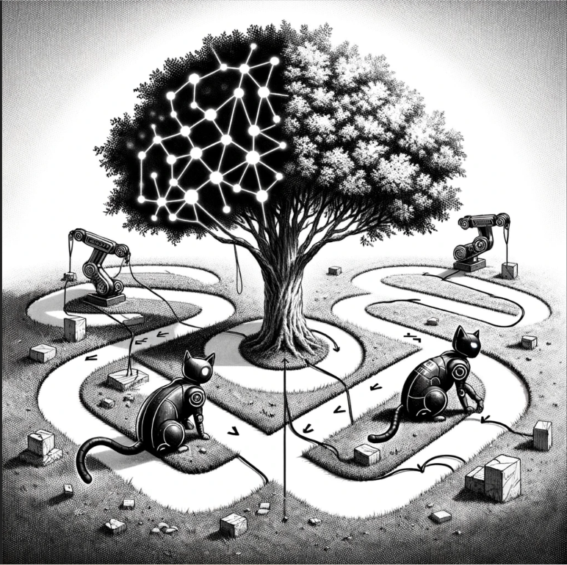****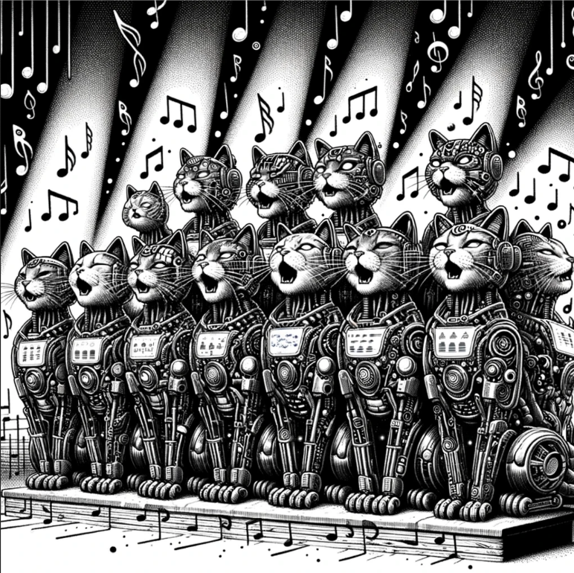**

Stacking

Bagging

Boosting

Tru-La-La

This is why decision trees are often used in ensembles - any anomaly in the data is enough for the model to perform incorrectly.

It's even better if the algorithms you use are unstable and highly dependent on the input data.

But if you take several less effective algorithms and teach them to correct each other, the quality of such a system will be better than any of the algorithms individually.

Many classifiers become regressors after a little tuning, for example **Decision Trees**.

In the real world, however, these simple regressors do not perform very well.

This is what we call an **Ensemble**.

Hmm, this confirms the similarity between regression and classification.

If regression produces a Straight line, it is **Linear**, if a curve, **Polynomial**. These are the two main types of regression.

**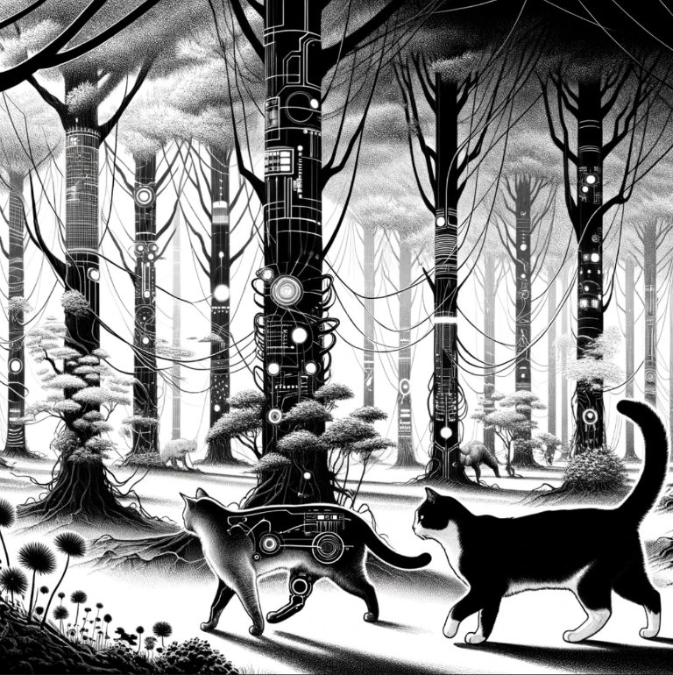****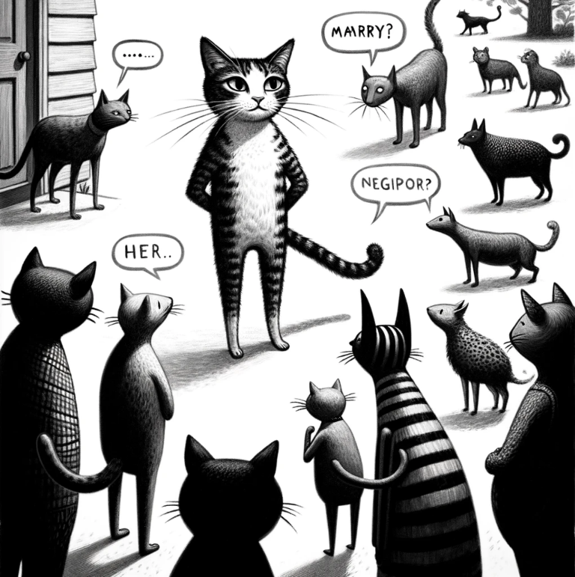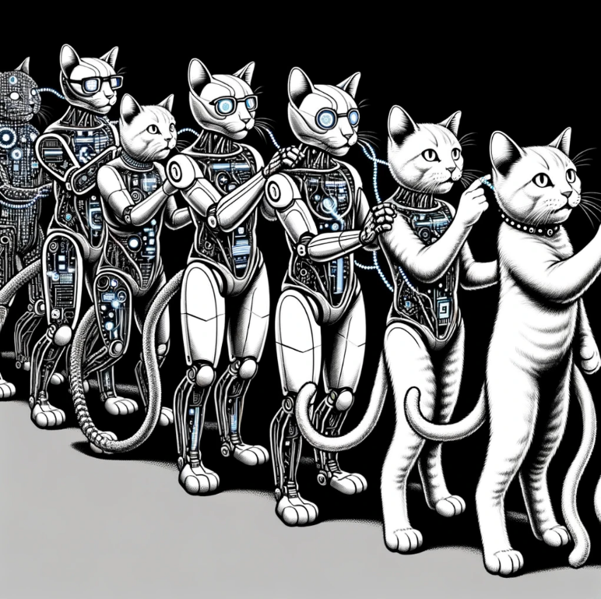**

**Stacking** trains several different algorithms and feeds their results into the last one, which makes the final decision.

As in the Begging, Boosting selects from the same data set, but not randomly.

In a new sample, we take the data that caused the previous algorithm to perform incorrectly.

In other words, we train a new algorithm on the mistakes of the previous one.

**Boosting** trains algorithms sequentially, with the next one focusing on the cases where the previous one made a mistake.

**Bagging** (aka Bootstrap AGGregatING) trains an algorithm many times on random samples. The data in the samples can be repeated. At the end, it averages the results.

It's like girls interviewing all their friends before deciding whether to date a guy.

The **Random Forest** is the most popular example of bootstrapping.

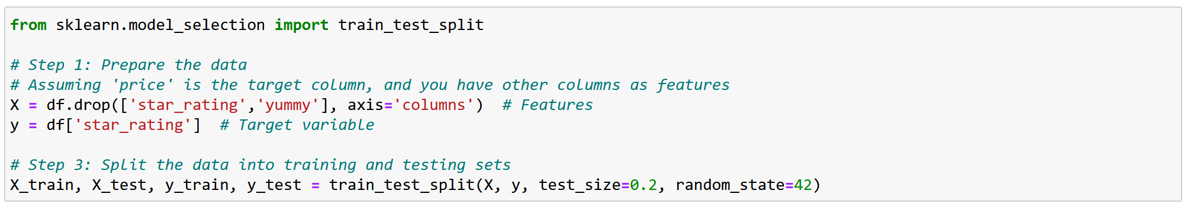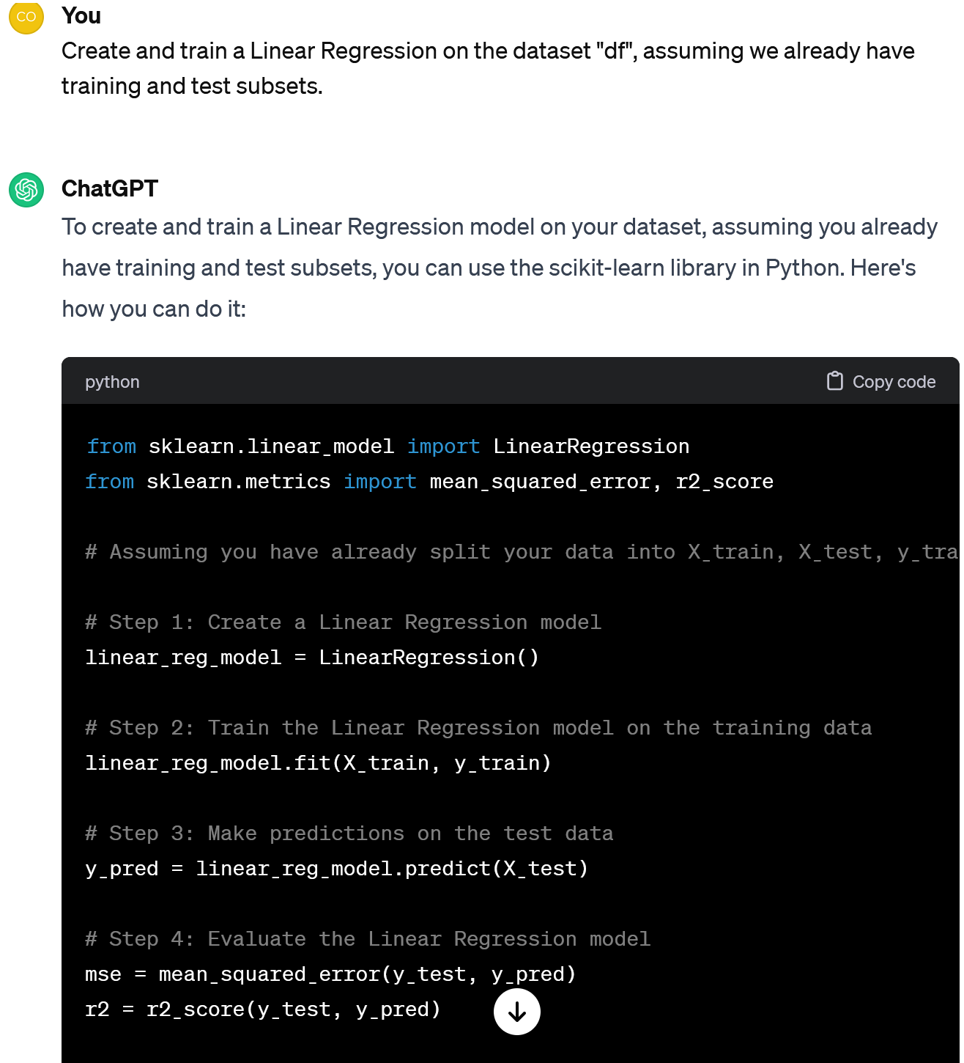Case 3. **Practice regression**

Could we develop the idea of predicting food quality with regressors?

Sure, for this we need a continuous "teacher", let it be "star_rating".

The MSE helps you to see how close your model's predictions are to the real data.

The smaller the MSE, the closer the model predictions are to the actual values.

Let's practise regression and go on with the prepared data set.

Ok. Let's start with a Linear Regressor.

But how do we see if it's OK or not?

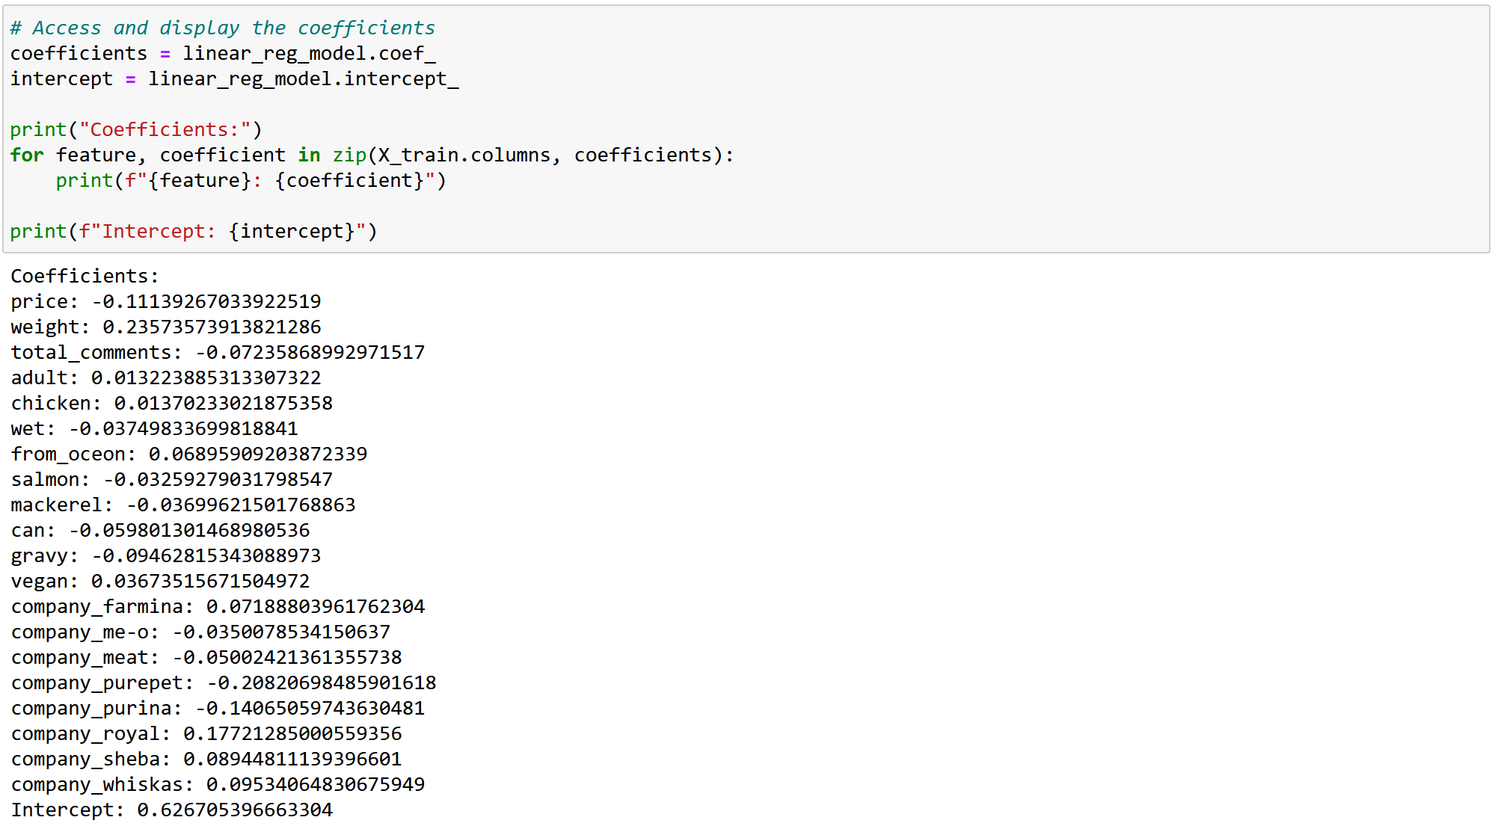****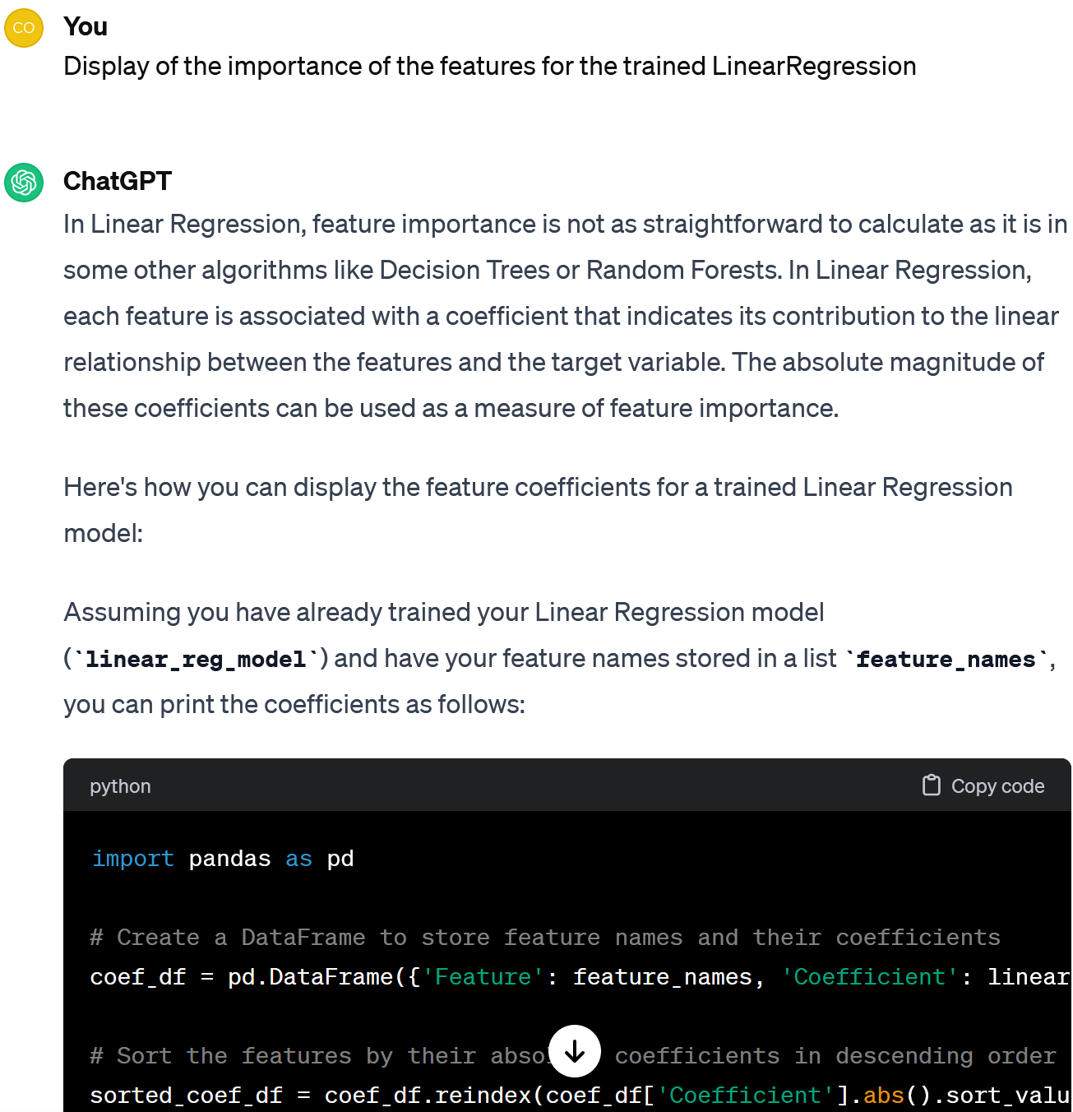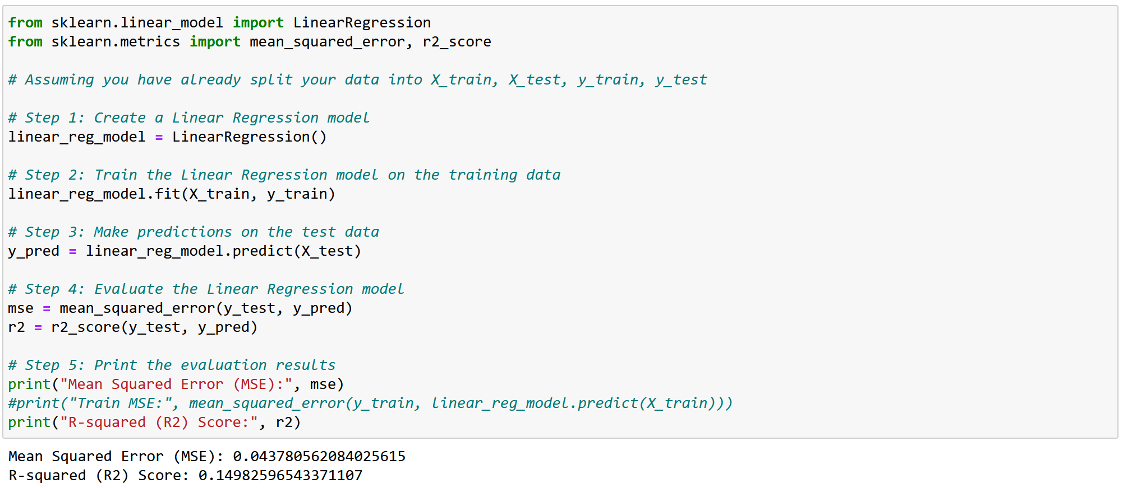

Anyway, as we can see from the coefficients, they consider the *price* (negative effect), and the *weight* (big packs are more attractive).

Perhaps, first they buy, then eat, and only then give feedback.

I see that the MSE is quite small. It seems, the model is ok.

Note that R2 is also small.

It means that the variance of the features explains only about 15% of the cats' preferences. The rest must be explained by other factors.

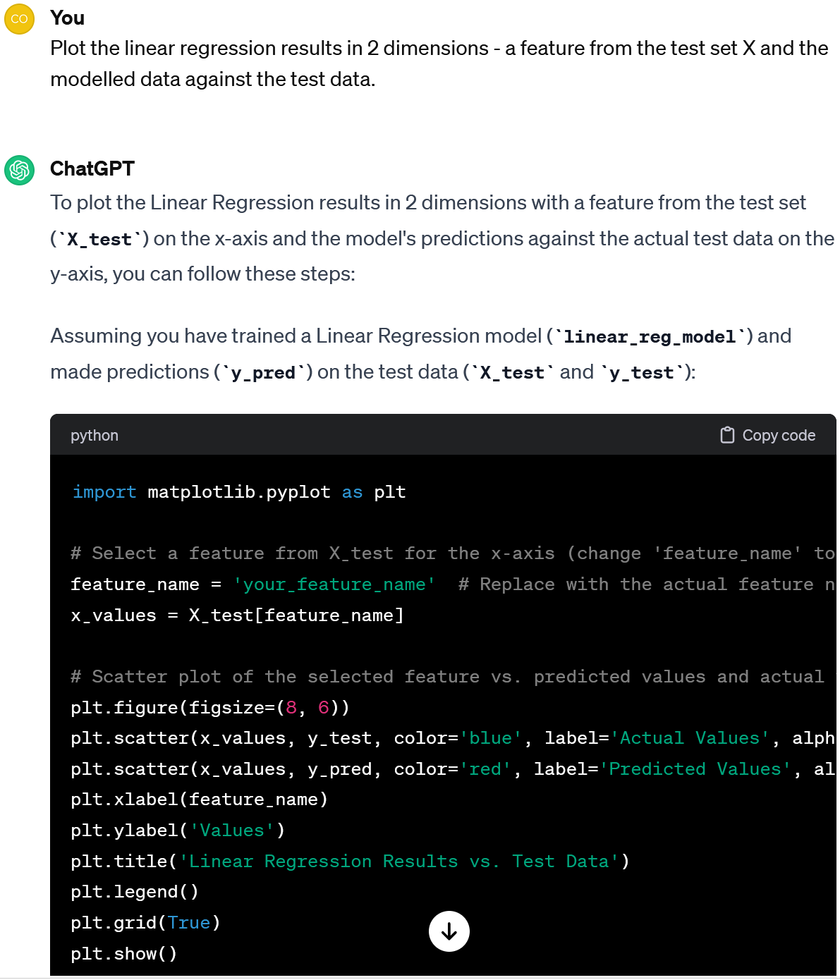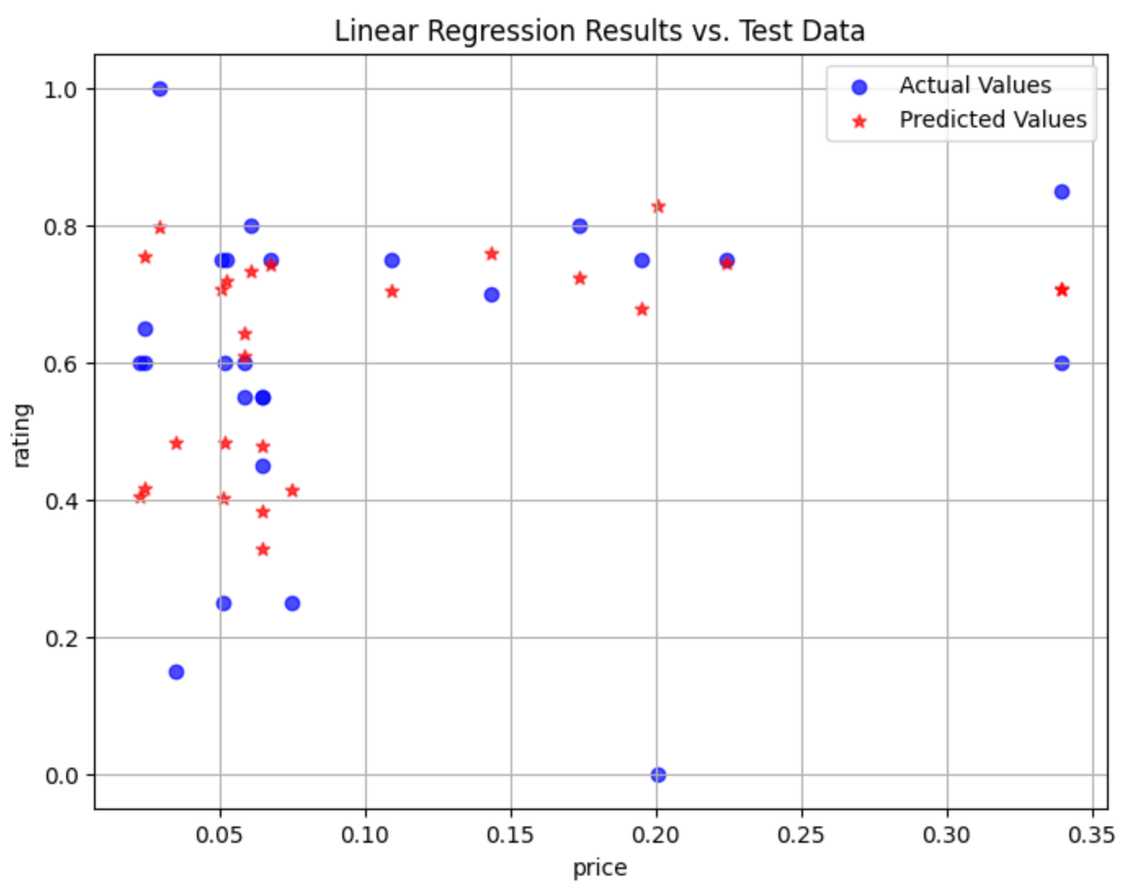

Sure. On the plot you can see how well our model predicts the rating.

Could we visualise the impact of price on the rating?

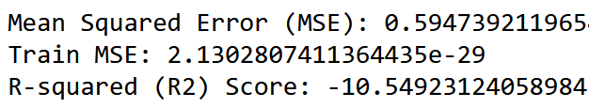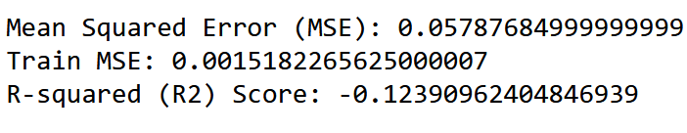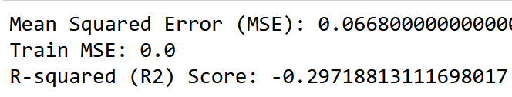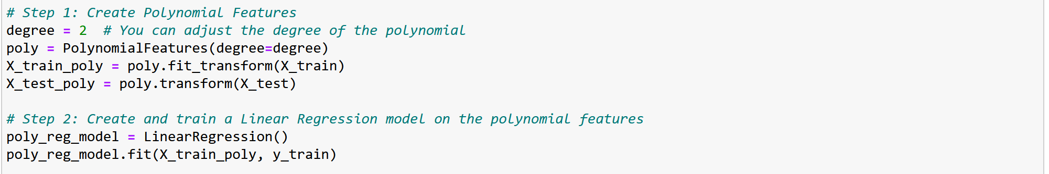 

Also, these models are overfitted.

The test MSE is significantly larger than the train MSE. For such a small data set, these functions are too complicated.

It means that these models predict worse than if you used the average as the predictor.

I see that for other Regressors R2 is negative. What does this mean?

Now we need to adjust the functions for the rest of the Regressors and compare the results.

Let's summarise. To create a Regressor, one have to:

1. Prepare the data: code the categorical features, select the "teacher" column, scale the data, and split it into training and test sets.

2. Build and train Regressors, e.g. Linear Regression, Polynomial Regression, Decision Trees, and Random Forest.

3. Compare their results (e.g. MSE and R2) and select the best one.

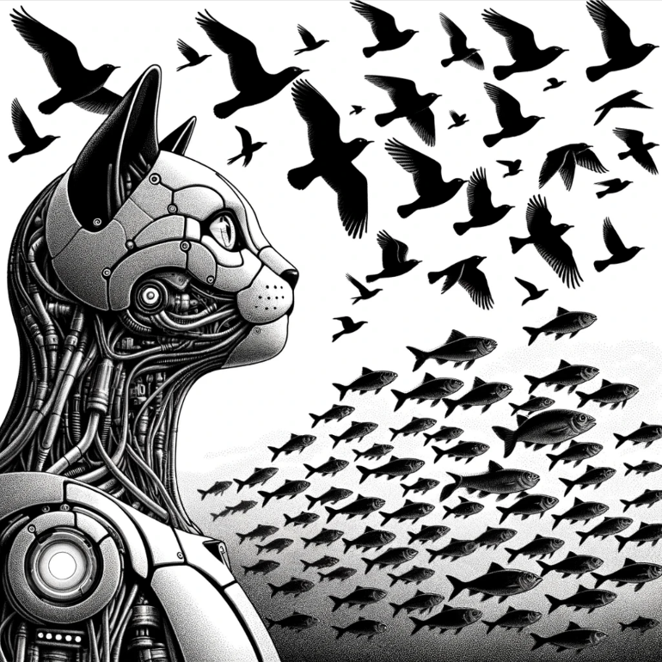**g**

2.3 **Clustering**

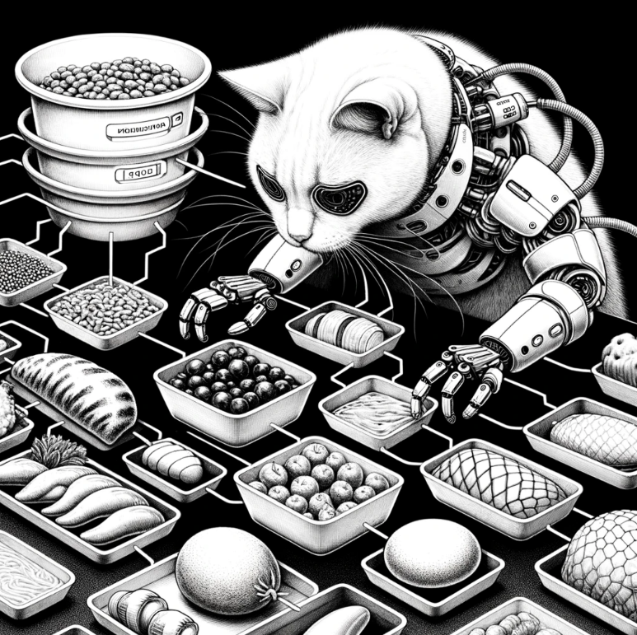

Clustering is also very similar to classification, but it does not use previously known classes, this is a case of unsupervised learning.

**Hierarchical clustering** is a way to group things into clusters step-by-step in two ways:

The number of clusters can be pre-set or left to the machine.

It looks for similar objects and groups them into clusters.

Let's consider those that help you choose a number of clusters (**Hierarchical Clustering**), those that require a fixed number (**K-Means**), and those that choose a number themselves (**DBSCAN**).

**Agglomerative**: We start with each thing in its own cluster and then join clusters as we go up.

**Divisive**: We start with everything in one cluster and then split it into smaller ones as we go down.

****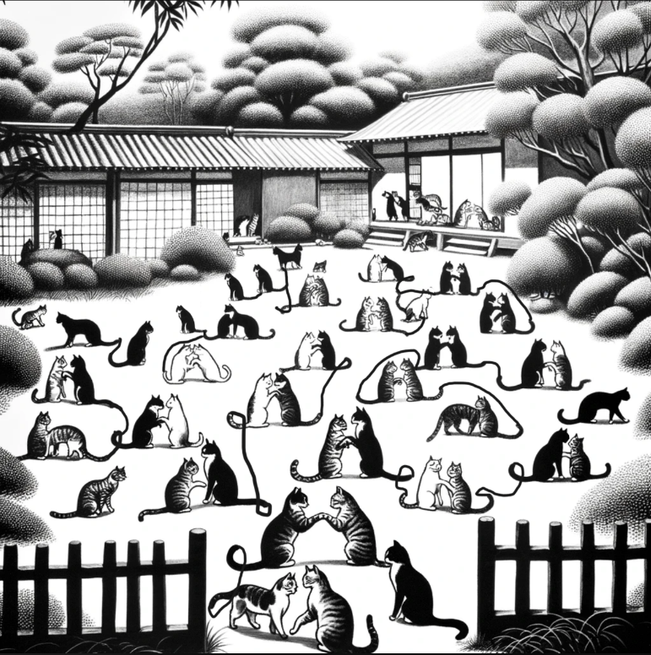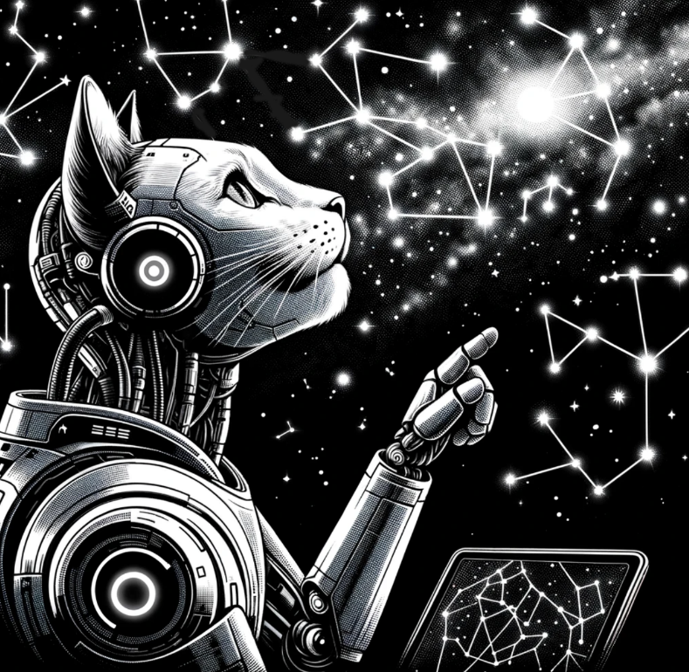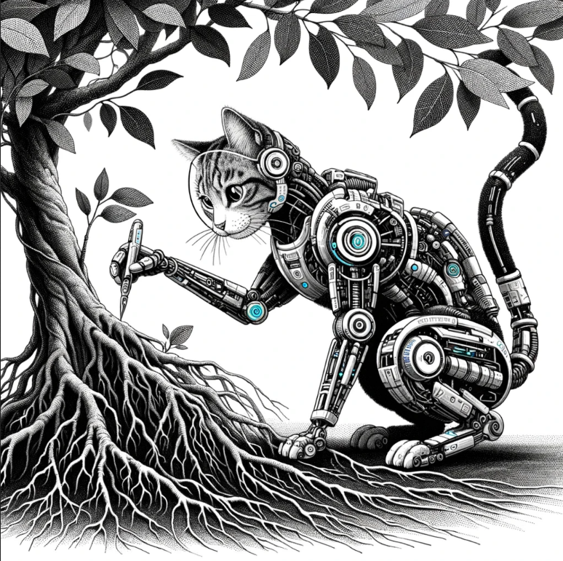

Cats that remain untouched are unusual, let's call them outliers.

Imagine cats in a yard. Find two of them sitting together, touching each other. Let them try to reach other cats.

Keep doing this until no one can reach anyone else, and that's a group.

Finding centroids is nice and easy. But real-world data is too complicated for K-Means to be effective.

Next, it moves each centroid to the centre of its constellation and repeats until the centroids stop moving.

It then assigns all the stars to the nearest centroid.

For example, to detect constellations, the **K-means** machine randomly places 12 points in the sky, called centroids.

**DBSCAN** finds groups of objects and makes clusters around them.

**K-means** clustering tries to divide N objects into K clusters. Each object goes into the cluster with the closest mean.

The results of **Hierarchical clustering** are often shown as a tree diagram called a dendrogram.

****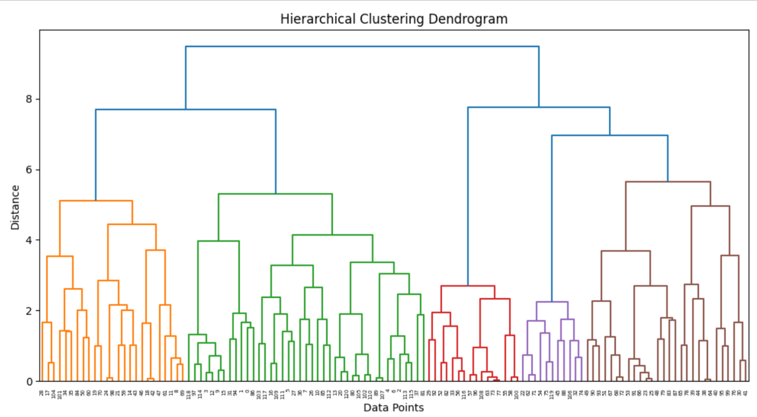****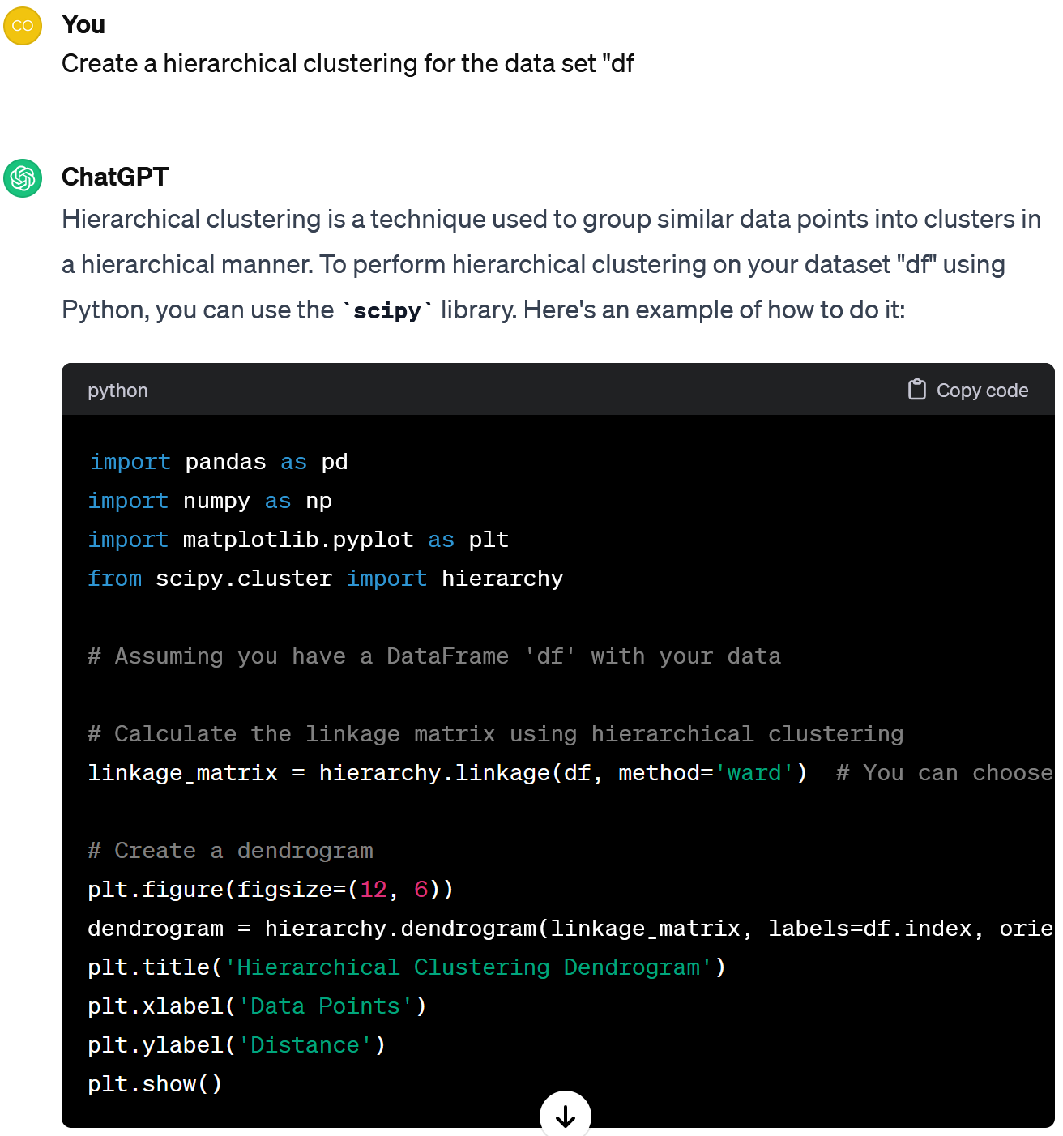Case 4. **Practice clustering**

Could we find some hidden structure in our prepared data?

Look, it recommends 5 clusters, 3 of which are slightly bigger than others.

Perhaps plotting the data as a dendogram will help us select a number of clusters.

Sure, let's try clustering.

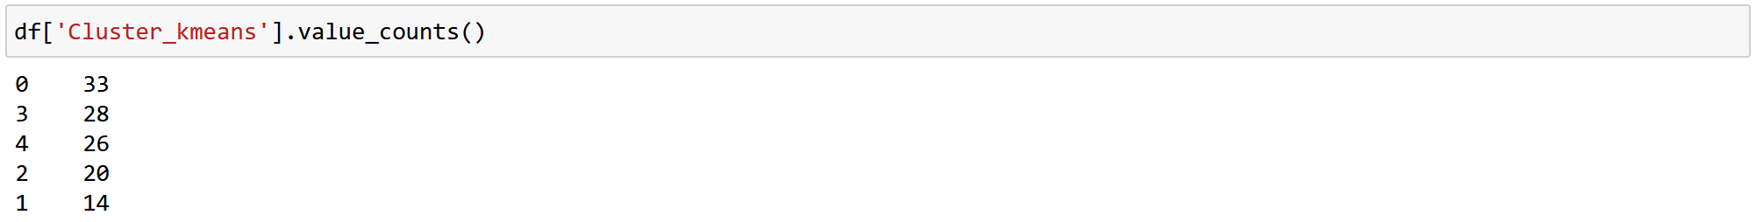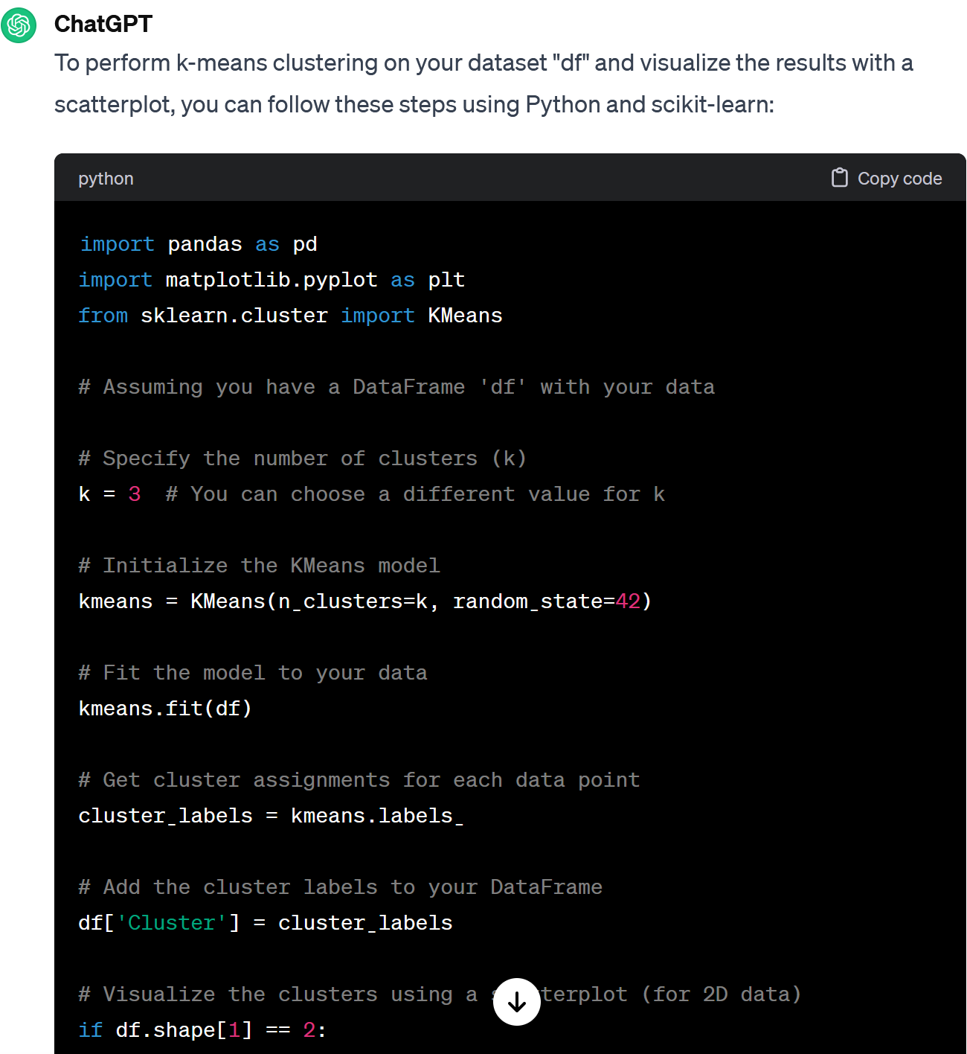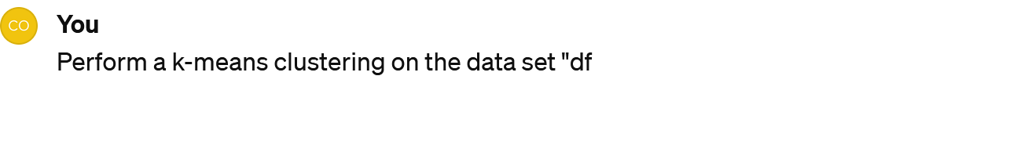

So let's apply k-means with k=5 and see how many observations are in each cluster.

Ok, here I see that all 5 clusters are full. But how does this help us to understand our data, the cats' preferences, etc.?

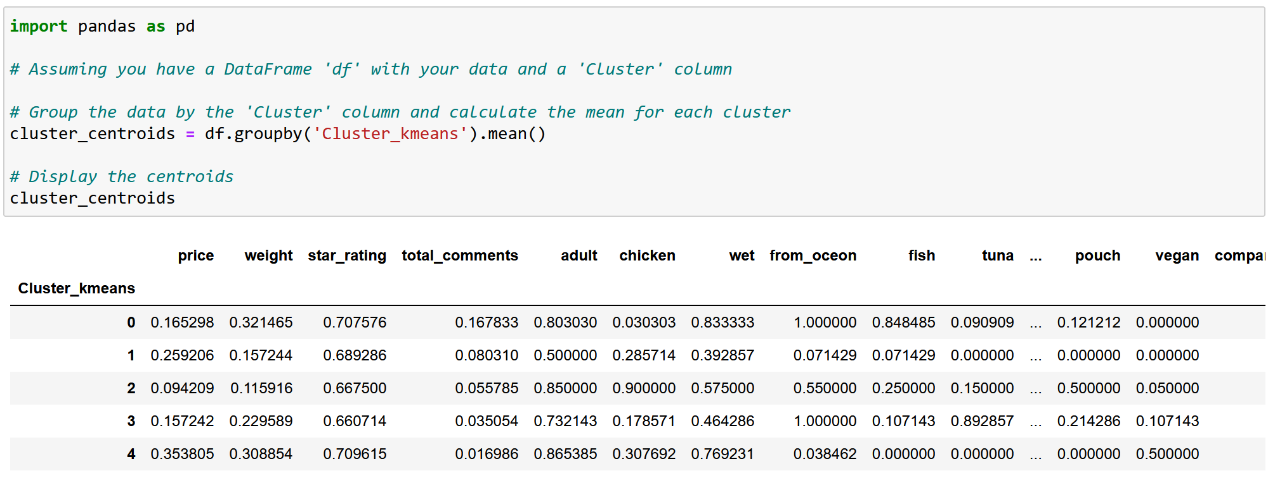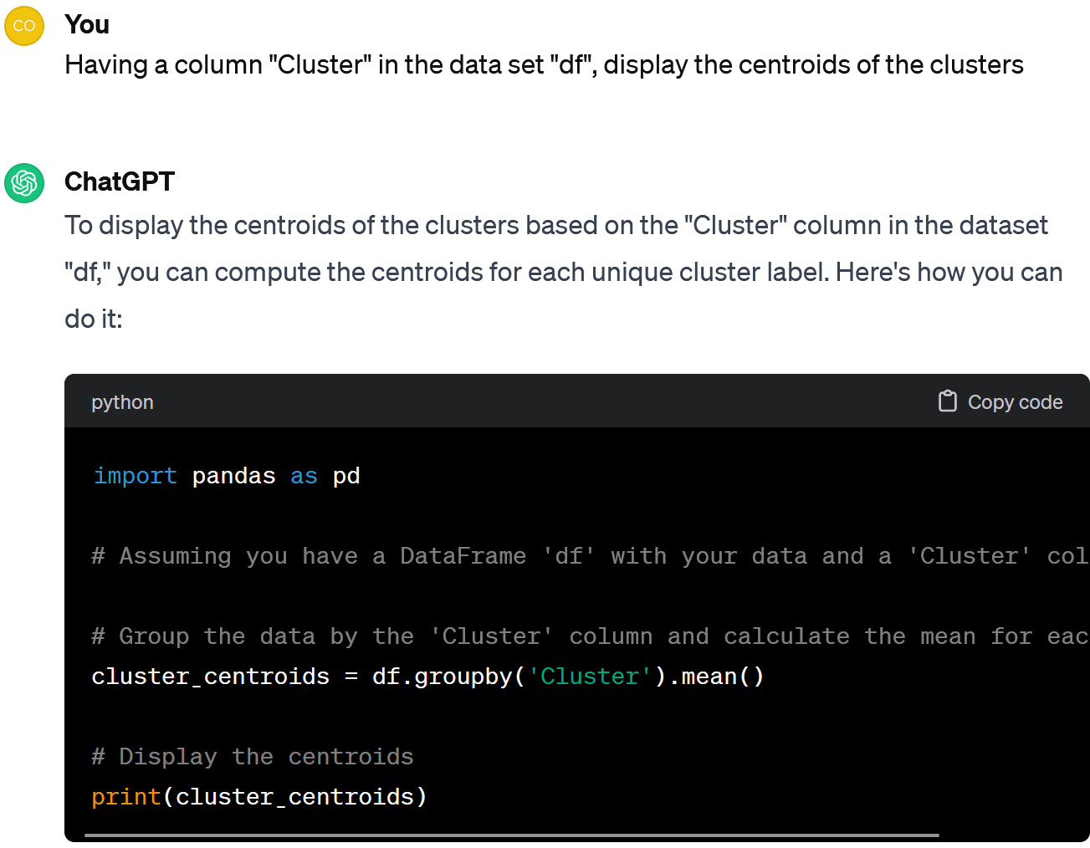

Cool, this could be useful for making a choice.

For example, in the first cluster (#0) there are cheap products in large packages. These products were highly rated by customers and received the most comments. This is a food for adult cats. It's probably wet, contains seafood and doesn't contain chicken.

We should analyse the centroids of the clusters.

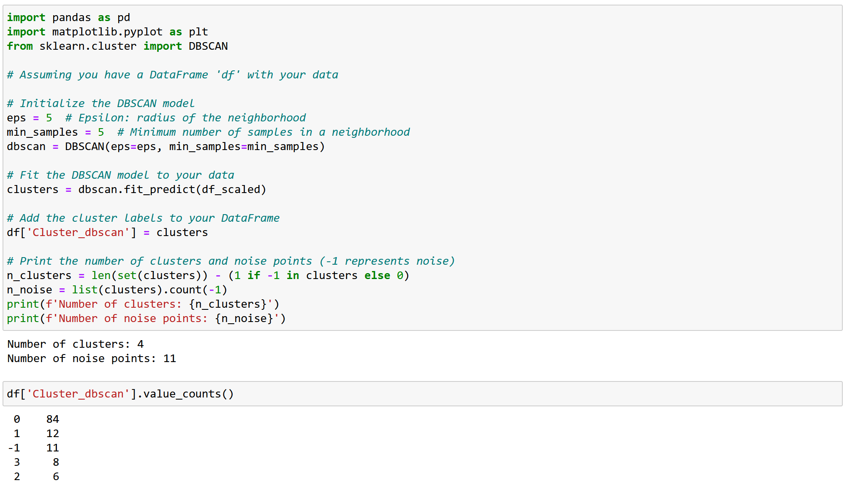

If we change a question a bit, we get a code for DBSCAN. Let's have a look at the results.





It seems that DBSCAN results are less useful in our case.

Most of the observations are in one cluster.

Here we have 4 clusters and 11 objects recognised as outliers.

Let's summarise. To perform Clustering, one have to:

1. Prepare the data: code the categorical features and scale the data.

2. Train Clustering algorithms, e.g. Hierarchical Clustering, K-Means, and DBSCAN.

3. Analyze the results (e.g. number of clusters, centroids).